A regular Meeting of the Board of Selectmen was held on Thursday July 13, 2017, at 6:45pm in the Francis O’Brien Meeting Room, 26 Bryant Street, Dedham, Massachusetts. Present were:

Dennis J. Teehan

James A. MacDonald

Michael L. Butler

Brendan G. Keogh

Dr. Teehan called the Meeting to order at 6:45 PM.

**PLEDGE OF ALLEGIANCE**

Led by Dr. Teehan.

**DEDHAM CITIZENS - OPEN DISCUSSION**

**Jessica Porter – 4 Willow Street**

Ms. Porter stated that she and Sarah Santos both attended the Parks and Recreation Commission meeting this past Monday to look at the update for Gonzalez Field design. Ms. Porter added that the plan was not on the Town’s website and they requested that it be put online. Ms. Porter then expressed her concerns regarding pedestrian access and safety and traffic in the square. Ms. Porter continued, saying that if an area is made safer for pedestrians there is less of a need for parking. Ms. Porter stated because this is in the process of being built now, it may be possible to look at the design and add a sidewalk, which was in a previous design, at the head of some parking spaces.

Mr. Kern stated that the two presentations that the designer for Parks and Rec made were significantly different as relates to the number parking spaces. Mr. Kern added that the decision made by the Board of Selectmen related to reducing the number of parking spaces by a considerable amount. Mr. Kern stated that he would be happy to go through Parks and Rec Board and identify whether they really think there is some flexibility with respect to the design to make a small modification. Mr. Kern informed Ms. Porter that he can find out if it is true or not.

Dr. Teehan stated that he believes this is a reasonable idea and something that the Board can certainly look into. Dr. Dean asked for opinions from the other Board members.

Mr. MacDonald stated that, as has been requested, Mr. Kern will take a look at it and if there is action the Board needs to take, he can report on that at the next meeting.

Mr. Butler stated that he agrees with Mr. McDonald.

Ms. Santos asked the Board why a portion of the walking trail to East Street was taken away.

Mr. Kern informed Ms. Santos that the decision is not made by the Board of Selectmen.

Ms. Santos asked who made the decision so she could ask them.

Mr. Kern responded that was Parks and Rec.

Mr. McDonald informed all that the only issue that the Parks and Rec Department asked the Board to weigh in on was the parking issue.

**DISCUSSION & VOTE RE: NEW OFFICER, P.F. CHANG’S CHINA BISTRO, 410 LEGACY PLACE**

Mr. MacDonald recused himself from the next three agenda items as they will go before the ABCC.

Andrew Upton, representing PF Chang’s, was before the Board.

Mr. Upton informed all that this is a change of officers at the corporate headquarters in Scottsdale Arizona and filing is mandated by the ABCC. Mr. Upton added there will be no change to any aspect of the restaurant here in Dedham.

Mr. Butler moved approval of the request by PF Chang’s for a new officer at the corporate level; seconded by Mr. Keogh. **On the Vote:** Mr. Keogh, yes; Dr. Teehan, yes; Mr. Butler, yes; Mr. Guilfoyle, absent; Mr. MacDonald, abstained.

**DISCUSSION & VOTE RE: CHANGE OF MANAGER FROM LAUREN COUGHLIN TO MEREDITH LOBSITZ, LEGAL SEAFOODS, LLC, D/B/A LEGAL C BAR, 736 LEGACY PLACE**

Donna Cruz, paralegal to the general counsel at the corporate offices of Legal Seafoods, and Meredith Lobsitz, the proposed Manager, were present before the Board.

Mr. Keogh asked Ms. Cruz to give some information regarding her previous Managerial experience.

Ms. Cruz informed all that she has been a General Manager with Legal Seafoods in Dedham for close to two years and was a General Manager for three years at other locations and has been in Managerial positions for 12 years total.

Mr. Keogh asked Ms. Lobsitz what changes will be made in terms of her responsibilities.

Ms. .Lobsitz informed all that the previous Manager is still with the company and has just changed locations. She continued by saying that her responsibilities as General Manager will not change.

Mr. Butler asked Ms. .Lobsitz what Legal Seafoods’ policy is on carding patrons.

Ms. Lobsitz informed all that they card anybody that looks under 40 years old.

Mr. Butler asked Ms. Lobsitz how she handles situations where a patron may have had too much to drink.

Ms. Lobsitz answered that the staff would immediately notify a Manager and they would immediately stop serving the patron and help get them home appropriately and safely.

Mr. Butler asked Ms. Lobsitz what she does when she finds a counterfeit ID.

Ms. Lobsitz informed all that she has never come across one but if she did she would notify the Police.

Mr. Butler asked Ms. Lobsitz what kind of device Legal Seafoods has for checking the authenticity of an ID.

Ms. Lobsitz informed all that the restaurant has three ID checking books on the premises.

Mr. Butler asked if they had anything electronic to check IDs.

Ms. Lobsitz answered know they do not.

Mr. Butler asked Ms. Lobsitz if she was familiar with Dedham’s rules and regulations regarding alcohol service.

Ms. Lobsitz answered yes.

Mr. Butler asked Ms. Lobitz if she was TIPS certified.

Ms. Lobsitz informed all that she was Serve Safe certified.

Mr. Butler asked Ms. Lobsitz how often Legal Seafoods talks to its staff about the importance of checking IDs.

Ms. Lobsitz answered daily, at all of our pre-meals meetings in the morning and the afternoon.

Mr. Butler moved approval of Legal Seafoods change of Manager from Lauren Coughlin to Meredith Lobsitz; seconded by Mr. Keogh. **On the Vote:** Mr. Keogh, yes; Dr. Teehan, yes; Mr. Butler, yes; Mr. Guilfoyle, absent; Mr. MacDonald, abstained.

**DISCUSSION & VOTE RE: TRANSFER OF ALL ALCOHOLIC RESTAURANT LICENSE FROM PEPPER DINING, INC. D/B/A CHILI’S GRILL & BAR RESTAURANT, 930 PROVICENSE HIGHWAY, DEDHAM TO MUSE PAINTBAR, LLC D/B/A MUSE PAINTBAR, 234 LEGACY PLACE AND APPROVAL OF SHANNON O’LEARY AS MANAGER, AND APPROVEL OF ENTERTAINMENT LICENSE**

Dr. Teehan stated that this is an agenda item that was carried forward to this meeting and asked Ms. Baker to refresh everybody’s minds regarding this agenda item.

Ms. Baker stated that for the purposes of consistency this agenda item was re-advertised for this evening, appropriately noting Ms. O’Leary as the proposed Manager of Record. Ms. Baker added that there are three actions before the Board this evening; a vote to transfer the license from Pepper Dining to MUSE Paint Bar, approval of Ms. O’Leary as the Manager and approval of an entertainment license.

Mr. Keogh asked Ms. O’Leary to describe her experience in the food industry.

Ms. O’Leary stated that she’s been with Muse for approximately two and half years and currently works as the Manager at the Foxboro/Patriot Place location. Ms. O’Leary added that she has seven years’ experience as a Manager and also experience as a server.

Mr. Keogh asked Ms. O’Leary how she would handle situation where patrons had too much to drink.

Ms. O’Leary informed all that there are fortunate that they have not had any major situations at the Foxboro location as they are only open for about a two and half hour window and patrons are painting the whole time. Ms. O’Leary added that for this reason is not a lot of time to over serve. The main focus is on the painting during the class and not the drinking. Ms. O’Leary continued, saying that if they were to have a situation, the staff is trained to go directly to a Manager to make sure the situation is handled correctly by offering them food or water and transportation home.

Mr. Keogh asked Ms. O’Leary how long the patrons stayed around after the session has ended.

Ms. O’Leary informed all that they take the picture and leave as there is no hanging around afterwards.

Mr. Butler asked Ms. O’Leary if the Foxboro location is had any violations in the past few years.

Ms. O’Leary answered it has not.

Mr. Butler asked Ms. O’Leary if she is read the rules and regulations pertaining to the service of alcohol in Dedham.

Ms. O’Leary answered yes I have.

Mr. Butler asked Ms. O’Leary if she checked every patron’s identification.

Ms. O’Leary informed all that they check for everyone under the age of 35.

Dr. Teehan stated that it looks like MUSE Paint Bar has a great system in place and the Town Legacy Place are fortunate to have them.

Mr. Keogh moved approval of the transfer of the all alcoholic restaurant license from Pepper Dining, Inc. d/b/a chili’s grill and bar restaurant, 930 Providence Hwy. to MUSE Paint LLC, d/b/a Muse Paint Bar, 254 Legacy Pl.; Seconded by Mr. Butler. **On the Vote:** Mr. Keogh, yes; Dr. Teehan, yes; Mr. Butler, yes; Mr. Guilfoyle, absent; Mr. MacDonald, abstained.

Mr. Keogh moved approval of Shannon O’Leary as Manager; seconded by Mr. Butler. **On the Vote:** Mr. Keogh, yes; Dr. Teehan, yes; Mr. Butler, yes; Mr. Guilfoyle, absent; Mr. MacDonald, abstained.

Mr. Keogh moved approval of an entertainment license for radio/TV; seconded by Mr. Butler. **On the Vote:** Mr. Keogh, yes; Dr. Teehan, yes; Mr. Butler, yes; Mr. Guilfoyle, absent; Mr. MacDonald, abstained.

Mr. Kern asked if there was an opening date.

Ms. O’Leary responded mid-October at the latest.

**DISCUSSION & VOTE RE: REQUEST FOR A ENTERTAINMENT LICENSE & SPECIAL APPEARANCES FOR HOOTERS OF DEDHAM, 850 PROVIDENCE HIGHWAY**

Colin Parker with Dedham Wings was present before the Board.

Mr. Parker stated that after discussing getting an entertainment license that Hooters needed to request a special permit for any activities related to a grand opening, specifically to have Budweiser Clydesdales and the End Zone Militia appear.

Dr. Teehan asked Mr. Parker what his role was with the company.

Mr. Parker answered that he runs operations for the company.

Mr. Kern informed all that as it stands now, the restaurant lacks a Certificate of Occupancy and the precursor to that which is the Certificate of Inspection. Mr. Kern added that the Building Inspectors have been involved with the enterprise through the last week and is working with the restaurant to get to the point where they are ready to proceed. Mr. Kern continued, saying that as it stands now they have neither of these Certificates.

Dr. Teehan asked Mr. Kern if these documents are required for every restaurant that opens in Dedham.

Mr. Kern informed all that the Certificate of Occupancy is required by anyone to occupy building.

Mr. McDonald asked Mr. Kern what the expectation of the Building Department is regarding issuing a full occupancy permit or a temporary one.

Mr. Kern answered that based on his conversation with the Building Commissioner today, he expects to be on-site tomorrow and if the things that need to be taken care of are taking care of, he is prepared to consider a Temporary Occupancy Permit.

Mr. Parker stated that that is consistent with his conversations with the building Commissioner today. Mr. Parker apologized for any concern that they’ve caused and went on to describe how the communication broke down.

Mr. McDonald stated that any action would have to be contingent on Hooters Receiving either the Temporary or the Permanent Occupancy Certificate. Mr. McDonald added that if they do not receive the Certificate they do not open. Mr. McDonald continued, saying that the request for the Budweiser Clydesdales on July 15, 2017 and the End Zone Militia on July 16, 2017.

Mr. Butler stated that in order for Hooters to open for business on Saturday, July 15, 2017, what Certificates they need to have in place in order to serve food and alcohol.

Mr. Kern answered a Certificate of Inspection and a Temporary or Permanent Certificate of Occupancy and need to also be cleared by the Board of Health.

Mr. Parker stated that they have met with the Board of Health and their next action is what is commonly known as a Post-Operational Inspection. Mr. Parker informed all that the electrical inspector, the plumbing inspector, the Health Department and the Fire Department have all signed off. Mr. Parker added that they have met with the third-party engineer in addition to the new Lieut. of fire prevention, it’s a matter of Ken Cimeno and his Department pulling all the pieces together. There were a couple of outstanding things that he felt were important to take care of.

Mr. Butler stated that if it were approved this evening it will be conditional on both the CO and the Board of Health. Mr. Butler asked if there is any other Department that would hold us up.

Ms. Baker answered no.

Dr. Teehan asked Mr. Parker if there would be gunfire from the militia.

Mr. Parker answered that they would like to re-create that. Mr. Parker added that this is been done at the last three openings, Springfield, Saugus and Shrewsbury and he thought it would be nice to do here in Dedham.

Kathleen O’Neill, Precinct 2, stated that her concerns about the Clydesdale horses. Ms. O’Neill stated that the parcel of land that we are speaking about is a very small one in an extremely busy area of Town. Ms. O’Neill continued, saying that she believes this is endangering the animals. Ms. O’Neill informed the Board that she believes this is a terrible idea and asked the Board to consider the safety of the horses and the safety of patrons.

Allison Staton, Woodleigh Road, Precinct 6, stated that if the sound of gunfire is approved, she would like to suggest that there be a Robo call to Town residents on Sunday morning informing them that there will be sound.

Mr. Keogh asked Mr. Parker how the Clydesdale will be brought in, where they will be standing and if Hooters has done this at other locations.

Mr. Parker answered that Hooters has done this at other locations. Mr. Parker stated that he would confidently say that Hooters has one of the best relationships with Anheuser-Busch in the country. Mr. Parker informed all that they’ve had restaurant openings where the entire hitch has been present. There will only be one horse at this opening. Mr. Parker described his experience with the Clydesdales and called them gentle and easy-going. Mr. Parker informed all that the horses are not asked to do anything they do not want to do and the handler has the last word as to what the animal does and where they go. Mr. Parker informed all that he spoke with a retailer in Killington Vermont that had the horses and they arranged to bring the animal inside the restaurant. Mr. Parker stated that the Dedham Health Department wants nothing to do with that, so we are not going to do that. Mr. Parker added that this will be one horse and some hay for two hours.

Ms. O’Neill asked Mr. Parker where they plan to put the horse in relation to parking and patrons visiting.

Mr. Parker answered that there are 240 spots in that parking lot which extends all the way behind the Owen Motors and the Tesla property. To Parker informed all that they share parking lot with the Best Tile Store and the AT&T store. Mr. Parker added that the trailer will be closer to the AT&T store and the horse would be brought around the building a few times.

Dr. Teehan stated that he’s not sure if this issue is within the purview or the scope of this Board and questioned what authority the Board has. Dr. Teehan continued, saying that if there is nothing else, he would like to move forward.

Mr. McDonald stated that in his 24 years on the Board he has approved a lot of personal appearances, many at the Adult Bookstore, they came in front of this Board as it was a First Amendment right. Mr. McDonald added that he is never had a situation like this with a horse. Mr. McDonnell continued, saying that the purpose of the Bylaw is for public safety reasons only. Mr. McDonald stated that you have to trust the handlers and believe they would never put them in a situation that is harmful to the animal or any patrons.

Mr. MacDonald moved approval of the request by Hooters for the appearance of a Clydesdale on July 15, 2017 contingent on a Police detail being present for Public Safety reasons, also contingent on Hooter’s Receipt of Certificate of Occupancy and all permits; seconded by Mr. Butler.

Mr. McDonald moved approval of the request by Hooters for the appearance of the End Zone Militia on July 16, 2017 contingent on the approval of the Chief of Police that there is no public safety issue with the firing of the blank muskets, also contingent on Hooter’s Receipt of Certificate of Occupancy and all permits; seconded by Mr. Butler.

Mr. Butler stated that the public safety rationale someone driving the decision regarding the additional Police Officer that Mr. MacDonald Recommended. Mr. Butler added that the concern about animal welfare was brought to his attention a week or two ago. Mr. Butler continued, saying that he is not come across any episodes involving Clydesdales over the last couple of years were there been injured. Mr. Butler stated that if there are residents interested in a policy that would tell the Town how to handle these differently, then that policy would have to be developed and go through the process involving other Town committees. Mr. Butler stated that he would be reluctant to deny a business request for animal welfare purposes, as it would be an ad hoc decision. Mr. Butler continued, saying that he would be more just and seeing a policy developed through the course that Town Government allows.

Mr. Butler stated that as far as a Robo call goes, he’s not sure how he reacts to that. Should the Board limit the number of rounds or volleys that the militia would fire? Mr. Butler asked Mr. Parker how many volleys are planned for Sunday.

Mr. Parker answered that he was unsure but possibly three or four. Mr. Parker informed all that the guys are extremely responsible, there’s no alcohol consumption, they are reenactment buffs and are not careless whatsoever. Mr. Parker added that they want to work with the Police Chief as they have in other Towns.

Jessica Porter stated that the reason she would encourage a Robo call is because there will be a lot of questions so at the very least the Town should notify the Police when the shooting will start.

Mr. Butler informed all that they could target areas of Dedham that might be affected by the firing of the muskets, for the Robo call.

Dr. Teehan stated that there is a motion, a second and we’ve had a discussion. Are there further comments from the Board?

Mr. McDonald stated that he would like to leave it up to the Chief to decide what type notification he thinks is in the best interest, so his officers definitely will know. Mr. McDonald reminded all that this type of gunfire happens a few times throughout the year in Dedham; Flag Day and of course on Memorial Day. Mr. McDonald added that the Board does not want to overreact. Mr. McDonald continued, saying that Mr. Butler’s suggestion of painting a few areas for a Robo call is a good idea.

Dr. Teehan asked if there are any further comments or questions from the Board Members. Dr. Teehan called for a vote.

**On the Vote:** Mr. Keogh, yes; Dr. Teehan, yes; Mr. Butler, yes; Mr. Guilfoyle, absent; Mr. MacDonald, yes.

Mr. MacDonald moved approval of Hooters request for an entertainment license for TV and jukebox within the restaurant; seconded by Mr. Keogh. **On the Vote:** Mr. Keogh, yes; Dr. Teehan, yes; Mr. Butler, yes; Mr. Guilfoyle, absent; Mr. MacDonald, yes.

**DISCUSSION & VOTE RE: ONE DAY LIQUOR LICENSES (7/27, 7/30 & 8/27), LEGACY PLACE**

Jessica Reed, Marketing Manager at Legacy Place, was present before the Board.

Ms. Reed stated that she would like to apply for three one-day liquor licenses for the dates that were just outlined.

Mr. Butler asked Ms. Reed if they had held one of these events recently.

Ms. Reed stated yes at the end of June.

Mr. Butler asked Ms. Reed how it worked out.

Ms. Reed answered that it went really well, there were about 30 people that attended and took a yoga class with Lulu lemon. Ms. Reed added that after the class they were given food from Whole Foods and beer from a craft Whole Foods Brewery. Ms. Reed informed all that half of the roadway in front of shake shack was blocked off for the fitness class and the other half was blocked off for the food and the beer afterwards.

Mr. Butler stated that it looks like two of the events you’re asking approval for follow the same format and the third one is on the garage roof.

Ms. Reed answered yes.

Mr. McDonald spoke to the fact that 3 Establishments in Legacy Pl. failed compliance checks and asked Ms. Reed to take back the Boards concerns to Beth Winbourne, General Manager of Legacy Place. Mr. McDonald stated that he would like to have Ms. Winbourne come into a future meeting to discuss how Legacy Place will handle this issue, along with how to educate the restaurant staff more thoroughly.

Mr. Butler asked Ms. Reed who will be checking the IDs of people that will be served alcohol.

Ms. Reed answered that they will have a two-step process, first, the IDs will be checked at the event check-in by the Beth Winbourne. Ms. Reed added that before they are served alcohol, the IDs will be checked again by the bartender who is TIPS certified. Ms. Reed continued, saying that it is a 21+ event and everyone will be ID.

Mr. Keogh stated that he noticed the Bike & Brew event on August 27 does allow minors to participate. Mr. Keogh asked Ms. Reed how far away the service area will be from the bike section.

Ms. Reed responded that the service bar area is completely blocked off and there will be metal crowd barriers blocking entrance to the bar area. All +21 attendees will have a wristband which allows them to drink alcohol. Ms. Reed stated that this event will have the same design as there June event, which was very successful. Ms. Reed continued, saying that they had a Police detail at the June event will have one at these three events.

Mr. Keogh asked Ms. Reed how many people they expected for the events.

Ms. Reed stated that the first event had 30 people and she is hoping for 50 people at the next event.

Mr. Butler moved approval of three one-day liquor licenses on the following dates to hold fitness and brew events; July 27 (7pm-8pm at Shake park; rain date August 3); July 30 (11:30am-12:30pm on P-3 Garage; rain date August 6); and August 27 (3pm-5pm at Shake park; rain date August 31); seconded by Mr. Keogh.

**DISCUSSION & VOTE RE: ONE DAY LIQUOR LICENSES FOR URSULINE ACADEMY (9/6, 7, 14, 22, 22, 23, 26; 10/5 & 12/7 AND REQUEST FROM DLIT FOR BANNER IN DEDHAM SQUARE FOR 5K RACE**

Janet Reynolds was present before the Board on behalf of Ursuline Academy. Ms. Reynolds stated that she was asking for approval of one-day liquor licenses for all of the fall events at Ursuline Academy. Ms. Reynolds added there will be TIPS certified bartender at each event.

Mr. Butler moved approval three one-day liquor licenses on the following dates for Ursuline Academy parent welcome Receptions (see September 6, 7 and 14; 5:30 PM to 8 PM); seconded by Mr. MacDonald. **On the Vote:** Mr. Keogh, yes; Dr. Teehan, yes; Mr. Butler, yes; Mr. Guilfoyle, absent; Mr. MacDonald, yes.

Mr. Butler moved approval two one-day liquor licenses on the following dates for Ursuline Academy stakeholder Receptions for New building (see September 22 and 26, 6-9 PM); seconded by Mr. Keogh. **On the Vote:** Mr. Keogh, yes; Dr. Teehan, yes; Mr. Butler, yes; Mr. Guilfoyle, absent; Mr. MacDonald, yes.

Mr. Butler moved approval of a one-day liquor license for Ursuline Academy Reunion Reception on September 23 from 6 PM to 9 PM; seconded by Mr. Keogh. **On the Vote:** Mr. Keogh, yes; Dr. Teehan, yes; Mr. Butler, yes; Mr. Guilfoyle, absent; Mr. MacDonald, yes.

Mr. Butler moved approval of a one-day liquor license for Ursaline Academy’s Serviam Society annual donor Reception on December 7 from 6 PM to 8:30 PM; seconded by Mr. Keogh. **On the Vote:** Mr. Keogh, yes; Dr. Teehan, yes; Mr. Butler, yes; Mr. Guilfoyle, absent; Mr. MacDonald, yes.

Mr. Butler moved approval of a one-day liquor license for Ursuline Academy senior parent Reception on October 5 from 6 PM to 8:30 PM; seconded by Mr. Keogh. **On the Vote:** Mr. Keogh, yes; Dr. Teehan, yes; Mr. Butler, yes; Mr. Guilfoyle, absent; Mr. MacDonald, yes.

Ms. Reynolds stated that DLIT (Dedham Library Innovation Team) is helping the Dedham Public Library with their second annual book it 5K run, taking place on August 19, 2017. Ms. Reynolds added that it starts and ends at the Main Library. Ms. Reynolds continued, saying DL IT is asking permission to hang a banner on the railing of the Keystone parking lot in Dedham Square from this weekend until the weekend of the race.

Mr. MacDonald moved approval of the request from the Dedham Library innovation team for a banner in Dedham Square in support of the Dedham Public Library’s second annual 5K book it race to be held on August 19, 2017; seconded by Mr. Keogh. **On the Vote:** Mr. Keogh, yes; Dr. Teehan, yes; Mr. Butler, yes; Mr. Guilfoyle, absent; Mr. MacDonald, yes.

**STATEMENTS FROM SUSTAINABILITY Committee Candidates**

Dr. Teehan stated that he would like to limit the statements to 90 seconds.

Emily Walton – 33 Eleanor Street

Ms. Walton laid out the reasons why she wants to be considered for the open seat. Ms. Walton added that she moved to Dedham about three and a half years ago and has been looking at ways to support the Town. Ms. Walton informed the Board she was a High School Science Teacher in Boston for seven years and her background is in Biology. She also stated that she has experience in research which gives her a good bridge of scientific and human aspects sustainability issues. Ms. Walton continued, saying that she loved working with students to come up with a realistic and actionable measures that they could take to have an impact on their communities and the environment. Ms. Walton informed the Board that she would love to continue that at the Town level.

Matt Simonson

Mr. Simonson stated that he would like to be considered for the Sustainability Committee. Mr. Simonson informed the Board that he grew up in Dedham and attended the school for Environmental Science. Mr. Simonson added that he was a Forest Firefighter for three years and work for the Department of Conservation and Recreation. Mr. Simonson continued, saying that he currently works for a Residential Solar Company and would like to find things to devote his time to outside of work. Mr. Simonson stated that having a younger Dedham resident that is in the Renewable Energy Field could be very useful to the committee.

Scott Thompson – 474 Washington Street

Mr. Thompson stated that he is a fourth-generation resident Dedham. Mr. Thompson informed the Board that he was on the Board for Bikes not Bombs for seven years and he was the chair in the clerk at different times. Mr. Thompson stated that one of the things you bring to the table is his experience in building a 34,000 ft.² platinum LEEDS certified building.

Leigh Hafrey – 718 High Street

Mr. Hafrey informed the Board that he is applying for a second term and the Sustainability Advisory Committee.

Mr. Hafrey stated that he moved to Dedham about six years ago and saw the committee as a way to understand the Town a little better. Mr. Hafrey added that he teaches Sustainability as part of his portfolio at MIT Sloan, the Business School at MIT. Mr. informed the Board that much of the focus in that teaching has included the environment he also pays a lot of attention to the question of social justice and the people aspect of what we see in sustainability for the future. Mr. Hafrey spoke about some of the projects discussed or worked on in his three years on the committee.

Michelle Kayserman – 3 Allen Lane

Ms. Kayserman informed the Board that she moved to Dedham three years ago and was recently part of the Dedham Revitalization Working Group that created the document for the Planning Board. Ms. Kayserman added that she works as a Civil Engineer specializing in Site Development, focusing on low-impact development. Ms. Kayserman informed the Board that she works very closely with Conservation, Planning and Zoning regarding the permitting process. Ms..Kayserman added that in terms of LEED Certification she has worked on certifying buildings in the LEED Accreditation. Ms. Kayserman stated that she has real work experience in this field and would like to be considered for the vacancy.

Diane Young

Ms. Young informed the Board that she has been a resident of Dedham for 12 years. Ms. Young stated that she was a strong driver in creating the Environmental committee at her work. Ms. Young added that through that she has experience running Global Environmental programs. Ms. Young continued, saying that she has a strong Communication background and a passion for the environment. Ms. Young informed the Board that a few of the things she has done at her company are running a global Earth week, park cleanups, farmers markets and Recycling drives. Ms. Young added that this year they had over 600 people involved. Ms. Young continued, saying that her experience and skill level is driving programs and she would love to participate in the committee.

Deborah Harrison

Ms. Harrison stated that she is grateful for the opportunity to speak to the Board this evening. Ms. Harrison informed the Board that she moved to Dedham in 1981 and she teaches Science at Noble & Greenough. Ms. Harrison added that in particular she teaches AP Environmental Science which is a hands-on immersion course. Mr. Harrison informed the Board that one of the projects they do is engage with the Dedham Westwood Water District learn about water quality issues. Ms. Harrison stated that she does volunteer work with fish and wildlife on the Cape with an endangered species that is a shorebird as well as volunteer work with Mass Audubon Society. Ms. Harrison stated that she believes in hands-on commitment to Environmental Stewardship.

Dr. Teehan praise the applicants for their high level of qualifications and urged them to consider other Boards and ways of serving the Town at the do not get appointed to this Board.

Dr. Teehan stated that they will vote on the appointment at the next meeting.

**DISCUSSION & VOTE RE: REQUEST TO HOLD BERNIE’S RUN ROAD RACE (10/1) AND BANNER IN DEDHAM SQUARE**

Dan Hart was present before the Board. Mr. Hart stated that he is hoping to hold the Bernie’s Run Road Race on October 1, 2017. Mr. Hart added that they have a few requests; the first is to host the race down in the Manor, the second is to be able to serve alcohol post-race in the parking lot of the Village Manor and the third is to hang a banner in Dedham Square prior to the race. Mr. Hart informed the Board that the race itself is very similar to years past and added that this is the 9th annual race. Mr. Hart added that they will work for the Dedham Police on the course and did not ask the Police for any road closures, we work with the Dedham Police and the auxiliaries to mitigate the traffic. Mr. Hart stated that they will have two Police details in the back lot of the village Manor pre and post-race. Mr. Hart informed all that Katie Gaffey from the Village Manor was present to answer any questions regarding the alcohol service.

Mr. Keogh asked where the alcohol would be served.

Ms. Gaffey answered that it would be in the parking lot will be cordoned off. Ms. Gaffey added that all the servers are TIPS certified.

Mr. MacDonald moved approval of the race route for Bernie’s run on Sunday, October 1, 2017 at 11:30 AM; seconded by Mr. Butler. **On the Vote:** Mr. Keogh, yes; Dr. Teehan, yes; Mr. Butler, yes; Mr. Guilfoyle, absent; Mr. MacDonald, yes.

Mr. MacDonald moved approval of outside service of alcohol at Bernie’s run October 1, 2017 from 11 AM to 3 PM as discussed and outlined; seconded by Mr. Butler. **On the Vote:** Mr. Keogh, yes; Dr. Teehan, yes; Mr. Butler, yes; Mr. Guilfoyle, absent; Mr. MacDonald, yes.

Mr. MacDonald moved approval for the placement of the banner in Dedham Square; seconded by Mr. Keogh. **On the Vote:** Mr. Keogh, yes; Dr. Teehan, yes; Mr. Butler, yes; Mr. Guilfoyle, absent; Mr. MacDonald, yes.

**DISCUSSION & VOTE RE: ORDER OF TAKING FOR BIRTCH STREET & LAYOUT OF QUARRY ROAD**

Jason Mammone, Town Engineer, was present before the Board.

Mr. Mammone stated that tonight is the final step to make Birch Street a public way. Mr. Mammone added that that is the order of taking. Mr. Mammone continued, saying that once that is signed and he Records it, it is done.

Mr. Butler stated that he would like to recognize the work that Mr. Mammone has done along with Attorney Eichman. Mr. Butler summed up the process and stated a few of the details regarding the benefits that Birch Street will now Receive.

Dr. Teehan stated that he believes the best part of this policy is that it is transparent and is there for any resident that wants to go through it.

Mr. Butler moved to approve and adopt the order of taking in the form prepared by Town Counsel to acquire by eminent domain a permanent easement for public way purposes within the layout of the portion of Birch Street, as voted and authorized under article 33 of the May 15, 2017 spring annual Town meeting; seconded by Mr. Keogh. **On the Vote:** Mr. Keogh, yes; Dr. Teehan, yes; Mr. Butler, yes; Mr. Guilfoyle, absent; Mr. MacDonald, yes.

Mr. Mammone stated that Quarry Road (a private way) was petitioning to become a public way. Mr. Mammone added that this is the point in the process where the layout plan has been provided for the Board to look at and the next step is for the Board to vote its intention to lay out the public way and refer the plan to the Planning Board for its report.

Mr. Keogh moved that the Board of Selectmen vote their intention to lay out a public way in accordance with the plan entitled “Street Acceptance Plan” as prepared by Civil View, Inc., with a date of June 22, 2017 and refer the layout plan to the Planning Board for its report; seconded by Mr. Butler.

Ms. Baker stated that the parties from Legal C are waiting to see what action the Board is going to take. Ms. Baker informed the Board that there is an item on the agenda regarding for establishments that failed the recent compliance check, service to a minor. Ms. Baker added that the establishments are Victory Bar & Grill, Legal C Bar, Aquitaine and Showcase Cinema.

Dr. Teehan stated that this is obviously a routine operation by Sgt. Buckley and Dedham Police Department, to make sure that restaurants that have liquor licenses are adhering to the liquor laws and regulations of Dedham.

Mr. Butler moved to call for violation hearings for failure to comply with service to a minor for Victory Bar & Grill, Legal C Bar, Aquitaine and Showcase Cinemas; seconded by Mr. Keogh. **On the Vote:** Mr. Keogh, yes; Dr. Teehan, yes; Mr. Butler, yes; Mr. Guilfoyle, absent; Mr. MacDonald, abstained.

Dr. Teehan stated that the hearings will be scheduled for either the August or September meeting.

Ms. Baker stated that the offenders will receive notice from the Town Manager’s Office.

**DISCUSSION WITH DEDHAM COALITION FOR DRUG AND ALCOHOL AWARENESS**

Jessica Gardner, Public Health Nurse, was present before the Board to give a presentation to update the Board on the accomplishments of the Dedham Coalition for Drug and Alcohol Awareness in 2016 and what they wish to accomplish in 2017, while educating the community in raising awareness about substance use.

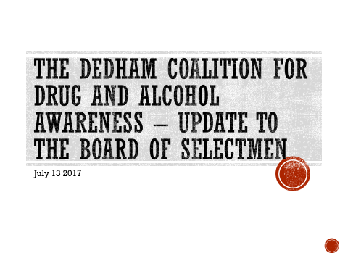

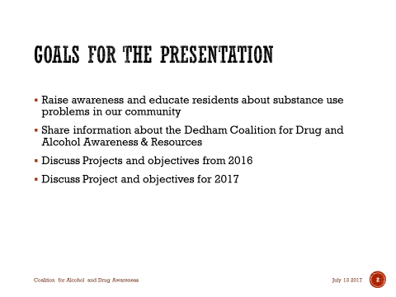

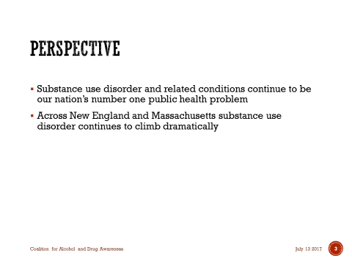

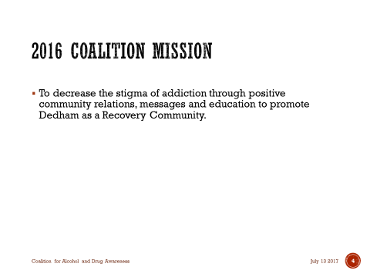

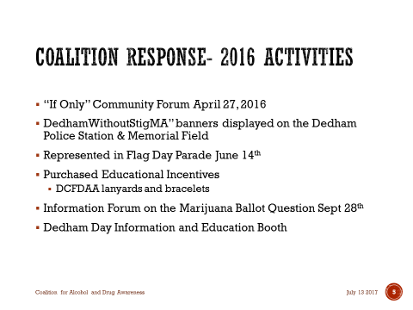

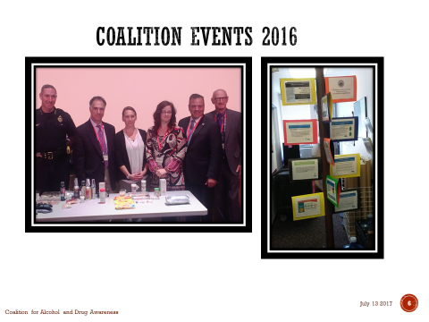

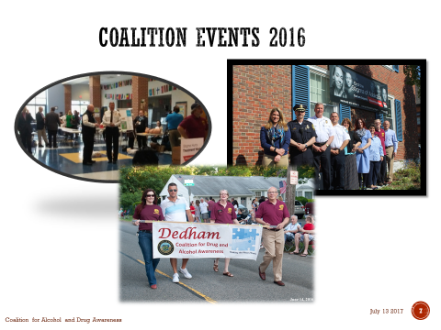

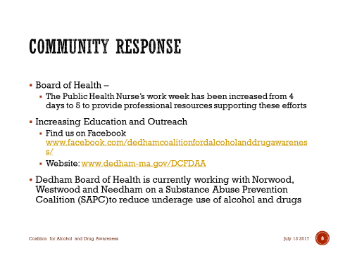

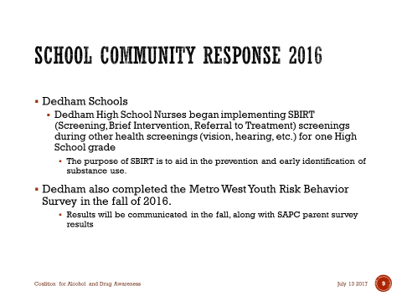

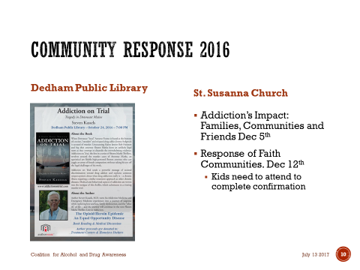

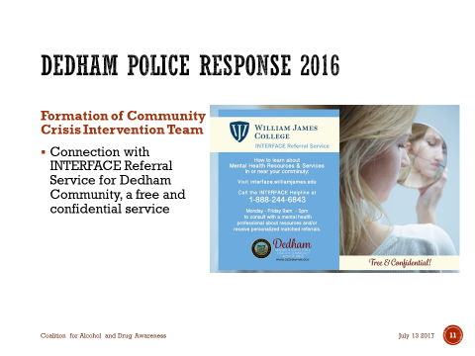



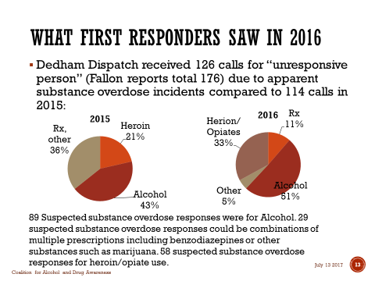

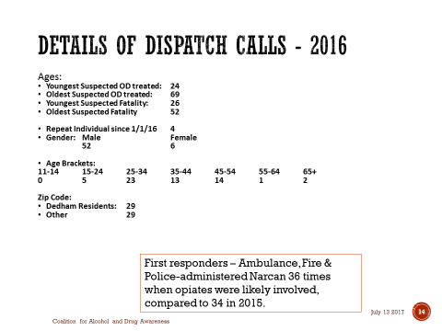

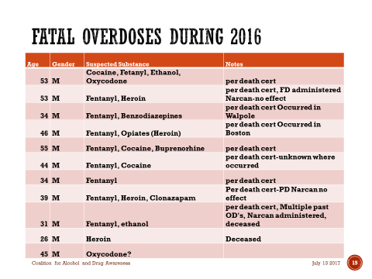

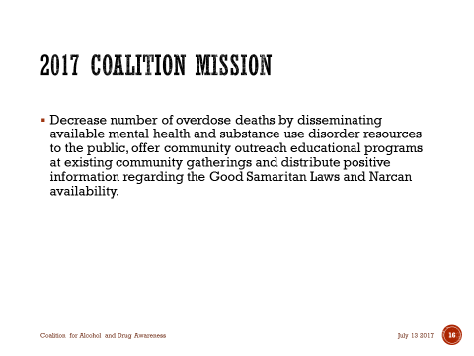

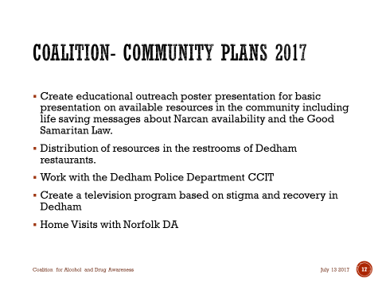







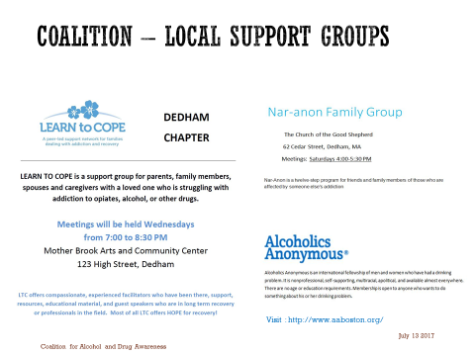



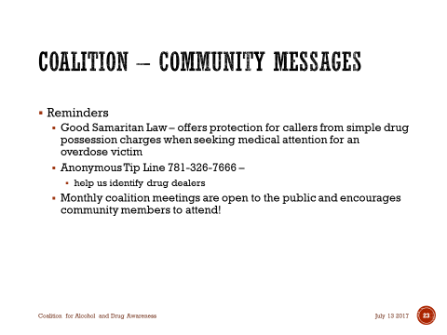

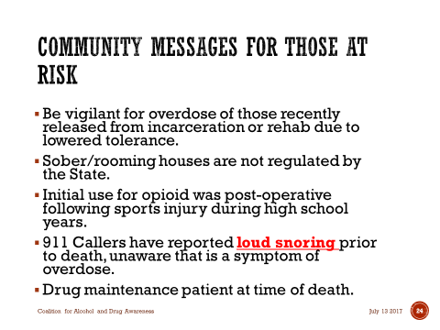



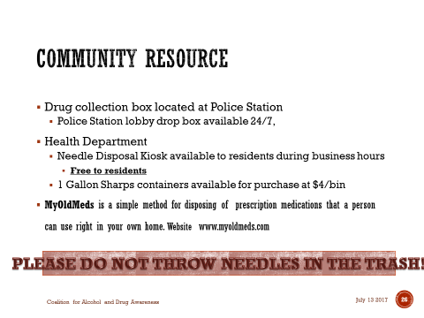

Dr. Teehan opened the floor up to comments from the Board.

Mr. Keogh thanked Ms. Gardner and the committee for all that they’ve done.

Mr. McDonald stated that he hopes this presentation will be going up on the Town’s website. Mr. McDonald added that it is important that we keep to residents up-to-date. Mr. McDonald informed all that this is a national epidemic and it is not just opiates, it is prescription drugs, nonprescription drugs, alcohol and marijuana. Mr. McDonald continued, saying the reason is to continue to put information out there to let people know that there is help if they wanted. Mr. MacDonald thanked Ms. Gardner for the work she does and also thanked Mr. Butler who is keenly involved in the coalition.

Mr. Butler stated that in her two years with the Town Ms. Gardner has brought a tremendous amount of energy and direction to the efforts of the coalition. Mr. Butler stated that the William James College interface referral service that the Town now has, which was found by Superintendent Mike Welch, is free to Dedham residents and it is being used by the Town. Mr. Butler added that superintendent, Mike Welch and Town Manager, Jim Kern figured out a way to split the annual charge. The service is free to Dedham residents and it is being used. Mr. Butler touched on the fact that Ms. Gardner has just started making home visits along with a person from the Norfolk County DAs office, to check on the addresses where overdoses have recently been reported. Mr. Butler informed all that they are building towards a model similar to the one Taunton uses, where they will have three or four people visiting the homes to help drive home that services are available. Mr. Butler stated that fortunately it is a minority of families that are affected by this, so communicating the availability of services is always difficult when you are trying to reach just a few. Mr. Butler informed all that students, grades 7 through 12, participated in the MetroWest youth risk behavior survey, which provides a really comprehensive view of risks. Mr. Butler added that the coalition and the schools work together to administer a parents survey this past March/April. About 400 or 500 parents participated. Mr. Butler continued, saying that in Dedham and in many suburban communities the people affected are in their 20s, 30s and 40s and the average age of the person going in an ambulance, in Dedham, for being unresponsive is 36. Mr. Butler stated that the data shows that in Dedham and most suburbs, people wrestling with this live with family. Mr. Butler added that this is a very complicated picture and most of the forces driving this are beyond our control. Mr. Butler continued, saying that almost everyone who has died from an overdose had fentanyl in their system. That all showed up in nine of the 11 fatalities last year. Three or four years ago you would not see that. Mr. Butler included saying that we have good team in place that is working on more communication regarding this epidemic.

Dr. Teehan thanked Mr. Butler for all the work he and the coalition have put into this. Dr. Teehan stated that what you have done is made a tremendous impact on a lot of people’s lives and the community. Dr. Teehan informed all that he spoke to a physician working at a clinic and they are actually seeing something called carfentanil, which is 10,000 times more potent than morphine. Dr. Teehan added that in a non-opioid tolerant person, that’s going to be fatal. It is not only going to present a huge risk to not only the people that use but also to our public safety personnel and first responders. Dr. Teehan thanked Ms. Gardner for all she does and for giving Dedham something to be proud of.

**TOWN MANAGER’S REPORT**

Substantial completion on the Town Hall/Senior Center is expected by September 15. Mr. Kern met with the Owner’s Project Manager (OPM) and a representative of the General Contractor to talk turkey on schedule. Mr. Kern added that we are still on schedule for a substantial completion, which is a contractual designation. Once that is met we will hire two contractors to move the FF&E (furniture, fixtures and equipment) as we are moving a good amount from this building. Mr. Kern stated that he expects that to be the first week in October. Mr. Kern added that the building itself is coming along and you can actually see what it will look like.

Mr. Kern informed all that Mike Butler, John Sisson, Andrea Terkelsen and he will be meeting next week on what will be somewhat like a newsletter. This is part of the Town’s effort communicate to the public the financial state of the Town as we’ve discussed.

Dr. Teehan informed all that they have been talking about some sort of informational material to get people factual information about some of things that are going on in this building and how it compares to other communities as well.

Mr. Kern stated that there are communities that send it out with the tax bill and stated that he has had communications about sending one out with the sewer bill. Mr. Kern added that they are putting together a document that does some comparisons with like communities and some trend information as it relates to Dedham itself and what actually happened with the average tax bill, Levy and a number of different things.

The Finance Committee reorganized at their meeting last week with Kevin Preston as the new Chairman.  We discussed an effort to provide some benchmarking to comparable communities over the next year.  That should dovetail with the effort to communicate our financial position to the public including some comparisons to similar communities and trends within Dedham.

Sheila Pransky, Council on Aging Dir. hosted a meeting of stakeholders to discuss the Council on Aging and the upcoming transition. Mr. Kern added that It was well attended and a productive meeting and Sheila will be scheduling another one before the opening.

We’ve had one meeting on the Abandoned Housing Initiative and we are almost done putting together a small list of properties and scheduling a visit from the AG’s office to evaluate the applicability of the program.

We had the post event meeting on the Flag Day parade and fireworks.  Mr. Kern added that it was an all-around an impressive night.  Credit to JuJu, the Public Safety Departments, Nancy Baker and the Public Safety Chiefs for some good planning and execution.  I’ve had almost unanimously positive response from the community.

**ACTION BY THE BOARD**

**REQUEST BY THE AMERICAL LEGION FOR OUTSIDE SERVICE OF ALCOHOL ON JULY 22, 2017**

Mr. MacDonald moved approval; seconded by Mr. Butler. **On the Vote:** Mr. Keogh, yes; Dr. Teehan, yes; Mr. Butler, yes; Mr. Guilfoyle, absent; Mr. MacDonald, yes.

**DRAINLAYER APPLICATIONS**

Feeney Brothers Excavation

RJV Construction Corp of Canton

Mr. Keogh moved approval; seconded by Mr. MacDonald. **On the Vote:** Mr. Keogh, yes; Dr. Teehan, yes; Mr. Butler, yes; Mr. Guilfoyle, absent; Mr. MacDonald, yes.

**REQUEST FOR A 1 DAY LIQUOR LICENSE FROM FRED ASTAIRE DANCE STUDIO, 619 HIGH STREET, JULY 16, 2017 FROM 6PM TO 11PM**

Mr. Butler moved approval; seconded by Mr. Keogh. **On the Vote:** Mr. Keogh, yes; Dr. Teehan, yes; Mr. Butler, yes; Mr. Guilfoyle, absent; Mr. MacDonald, yes.

**REQUEST FOR A 1 DAY LIQUOR LICENSE FOR THE RIDE FOR FOOD, SEPTEMBER 24, 2017, FROM 11AM – 1PM**

Mr. Butler moved approval; seconded by Mr. Keogh. **On the Vote:** Mr. Keogh, yes; Dr. Teehan, yes; Mr. Butler, yes; Mr. Guilfoyle, absent; Mr. MacDonald, yes.

**MINUTES APPROVAL – 6/15/17**

Mr. Butler moved approval; seconded by Mr. Keogh. **On the Vote:** Mr. Keogh, yes; Dr. Teehan, yes; Mr. Butler, yes; Mr. Guilfoyle, absent; Mr. MacDonald, yes.

**ITEMS NOT ON AGENDA**

Mr. MacDonald moved approval to take four items not on the agenda; seconded by Mr. Butler. **On the Vote:** Mr. Keogh, yes; Dr. Teehan, yes; Mr. Butler, yes; Mr. Guilfoyle, absent; Mr. MacDonald, yes.

**REQUEST FROM DEDHAM MOOSE CLUB FOR OUTSIDE SERVICE OF ALCOHOL ON JULY 26, AUGUST 2, 9, 16, 23 & 26 FOR THEIR HORSESHOE TOURNAMENTS**

Mr. Keogh moved approval; seconded by Mr. Butler. **On the Vote:** Mr. Keogh, yes; Dr. Teehan, yes; Mr. Butler, yes; Mr. Guilfoyle, absent; Mr. MacDonald, yes.

**GAINSVILLE ROAD BLOCK PARTY REQUEST, AUGUST 27**

Mr. Butler moved approval; seconded by Mr. Keogh. **On the Vote:** Mr. Butler, yes; Dr. Teehan, yes; Mr. Keogh, yes; Mr. Guilfoyle, absent; Mr. MacDonald, yes.

**REQUEST FOR SIGN AT VILLAGE CEMETERY**

Mr. Keogh moved approval; seconded by Mr. Butler. **On the Vote:** Mr. Keogh, yes; Dr. Teehan, yes; Mr. Butler, yes; Mr. Guilfoyle, absent; Mr. MacDonald, yes.

**REQUEST FOR EMERGENCY NO PARKING SIGNS ON RUSTCRAFT ROAD**

Mr. Butler moved that the Board of Selectmen, with respect to urgency for Public Safety, amend Part 1, Scheduled No. 1 of the traffic regulations to alter the existing “no parking anytime” restriction on both sides of Rustcraft road from Central Avenue to 900 feet westerly of Central Avenue to both sides of Rustcraft road from Central Avenue to 1150 feet westerly of Central Avenue; seconded by Mr. MacDonald. **On the Vote:** Mr. Keogh, yes; Dr. Teehan, yes; Mr. Butler, yes; Mr. Guilfoyle, absent; Mr. MacDonald, yes.

Ms. Baker informed all that there were a series of events coming up in conjunction with the Dedham Police Department’s National Night Out:

July 30, 2017 softball game between the Dedham Police and High School students, from 7-9PM at

Condon Park

July 31, 2017 open house at the Dedham Police Station from 9:30AM – 2PM, 600 High Street

July 31, 2017 Oakdale Square Ice Cream Social from 6:30 – 7:30PM

August 1, 2017 Main Library - Children’s Story Time with a public safety theme, 10:30-1:30AM

August 1, 2017 Special Tour of Dedham Police Station for seniors, 1-2PM, followed by coffee with a cop

from 2-3PM

August 1, 2017 Try it Tuesday Tie Dye Event at the Main Library from 3:30-4:30PM

August 1, 2017 Movie Night, Condon Park from 7-8PM

August 1, 2017 Flash light Manor Neighborhood Walk from 7:30-8:30PM

Ms. Baker added that all of these events on the Town and Police websites.

**OLD/NEW BUSINESS**

Mr. Butler thanked the organizers of this year’s four on the fourth Road race, which raises money for cancer research and is inspired by the indomitable spirit of Sally Nasar.

Mr. Keogh wished his mother happy 83rd birthday.

Mr. McDonald stated that the Flag Day parade showed that Dedham can come together for these events and community involvement. Mr. McDonald added that when JuJu came to a meeting and mentioned fireworks at the Flag Day parade, some people were skeptical about it. But JuJu persisted and it was an amazing community day and quite a spectacle. Mr. McDonald informed all that DCR has fixed the fence at Vinerock and we are just waiting for signs regarding no dumping. Mr. McDonald mentioned the sewer rate stated that to keep that on everybody’s mind during the slow summer season.

Mr. McDonald moved to adjourn the meeting; seconded by Mr. Keogh. **On the Vote:** Mr. Keogh, yes; Dr. Teehan, yes; Mr. Butler, yes; Mr. Guilfoyle, absent; Mr. MacDonald, yes.

The Meeting was adjourned 8:54PM.

The next Meeting is scheduled for Thursday August 24, 2017 at 7p.m. This is to certify that the above is a true and accurate Record of the Minutes of the Selectmen’s Meeting held on July 13, 2017, which minutes were approved on August 24, 2017.

________________________

Dennis Teehan, Jr. - Chairman