A regular meeting of the Board of Selectmen was held on Thursday October 13, 2016, at 7pm in the Francis O’Brien Meeting Room, 26 Bryant Street, Dedham, Massachusetts. Present were:

Dennis J. Guilfoyle

Dennis J. Teehan

James A. MacDonald

Michael L. Butler

Brendan G. Keogh

Mr. Guilfoyle called the meeting to order at 7 p.m.

Mr. Guilfoyle reminded all that the meeting was being shown live on Dedham TV, streamed over the internet and recorded for future broadcasts.

**PLEDGE OF ALLEGIANCE**

Led by Representative Mr. Guilfoyle.

**DEDHAM CITIZENS - OPEN DISCUSSION**

Broc Jackson – 328, 330, 332 East Street

Mr. Jackson read the following statement:

My name is Broc Johnson. I am owner and occupier of a three family house at 328, 330 and 332 East St. in Dedham. When I purchased my home in 2004, there was a nice grass field behind my house with no signs of construction or staging. Five months later my neighbor, the owner the field, at 513 High St. was allowed to rent out his property for construction staging. When I purchased my property, according to Dedham's records, my neighbor’s property was zoned half commercial space and half residential space. The residential space is located directly behind my house. From 2005 to 2010, my neighbor was allowed to rent his entire field for the state’s “Route One Bridge Reconstruction Project”. During that time I made several visits to the Town Hall to complain to the Building Inspector about the trucks making beeping sounds and the loading and unloading of gravel, rocks and other building materials throughout the night in the field. I was told that I was right and that they were not allowed to do that work at night. However, he stated that even if he were to fine the state, the state would not pay the fines. So there was nothing to be done.

From 2012 to 2014, my neighbor again rented out this field. This time it was to the Town of Dedham for "the Dedham Square Improvement Project." I complained about the night work again. This time I was told by the Town Building Inspector that I was only one complaint and was in the Town's best interest to get the work done in the evening. This may be make sense because when you go to the planning Board's question-and-answer page for this project clearly states "provisions in the construction contract will limit the amount of work that can be undertaken at any given time to reduce the impact to businesses." However, this means a lot of night work. At no time were the residents of Dedham taken into consideration on how this noise in the evening and early morning hours would impact their lives.

My neighbor was allowed to rent his field again starting in 2015. This time it was a federal project, the Algonquin Pipeline Project. This project is still in operation. During the past summer. The project had two working shifts. The first shift came in from 7 AM until 4 PM and the second shift work from 7 PM until four or 5 AM. After numerous complaints, the Algonquin people bought me a Bose headset to sleep with and gave me a 5' x 5' sound board that I was supposed to drill to the outside of my house over my bedroom window. I was told by our state rep that they should be putting me up at a hotel because of the noise but the pipeline people told me that if they did that, then they would have to put the whole neighborhood in a hotel which would be too costly.

Due to this constant disturbance, I was forced to move out of my house for two months. During this time. My neighbors on either side of my property actually moved out because of the noise. Throughout the years I have lost tenants and many times I have been unable to rent my property. Due to the constant noise day and night it in the staging area. When I looked for legal counsel in the Dedham area recently to work on this issue, I was told by this Attorney that he sits as Chairman on the Dedham Planning Board and Paul Cocci, the owner of the field behind the house, was a former client of his so he couldn't help me because there would be a conflict of interest.

Since May of this year, I've sent over 20 e-mails going back and forth with all of you on the Board about this issue. My most recent e-mail to all of you stated that I'm getting a petition together with all of my neighbors. Within 24 hours of this e-mail being sent, the Town Building Inspector called me to discuss three small cardboard signs. I had on Dedham common area about my 5K obstacle race. He told me I couldn't have my race, he told me I had to take my signs down and investigated my business.

Year after year, my neighbor is allowed to rent out and make a ton of money on his lot as a staging area to anyone and everyone with no restrictions. It's either a state project, which no one wants to enforce the laws on night work, or it's a Town project that somehow is just in the Town's best interest to do night work, so we won't enforce the quiet time laws or its federal project that supersedes all Town laws and you can't do anything.

I've gone to my state rep, I've gone to the Town Building Inspector, have gone to the police department, and that made everyone on the Board in front of me aware of the situation. Time and time again all I hear is that there is nothing we can do. For some reason Paul Cocci either gets the pass or is being protected. I'd like to quote my last e-mail received from one of you on the Board. As far as the staging of equipment, Spectra project continues and being a federal project is exempt from zoning. At the conclusion of that project, the use of that site for a staging area should end, unless there is another exempt project that follows it.”

I'm asking for the Board to put this property on the agenda for review to prevent its use of noisemaking equipment and porta potties that would or could be used day and night without any consideration to neighbors or any recourse of the companies using the property. In the future, the residents of this neighborhood should not suffer from another exempt project. The Town does not let any other businesses in Town do construction work at night. Also, the Town is actively working to improve the situation for the neighborhood near the Amazon warehouse so that they are not disturbed by Amazon trucks, delivery vans, parking or other noise. The same consideration should be given to my neighborhood as this situation has gone on far too long.

I'm aware of another project that could start next summer at the soccer field by my house. I would like to prevent this field from being a staging area again.

Thank you.

Mr. Guilfoyle stated that the Board has received his emails and it is a concern. Mr. Gulfoyle added that Mr. Jackson’s neighborhood has been tortured for the last many year, especially Harris and East streets.

Mr. Kern stated that he has had a number of correspondences back-and-forth with Mr. Jackson and as he knows we have to be careful to make promises that cannot be kept. Mr. Kern added that he does not take issue with almost everything Mr. Jackson has said him and stated that Mr. Jackson has communicated how unfair he feels this is.

Mr. Butler stated that Mr. Jackson is looking for information about the rest of October and November as there is still some paving to be done. Mr. Butler asked Mr. Kern to provide Mr. Jackson with a schedule containing dates, times and locations of road work in October and November.

Mr. Kern stated he would provide that, for Mr. Jackson.

Mr. MacDonald asked Mr. Jackson to e-mail his statement to the Board members.

Mr. Jackson stated that he will do that.

Dr. Teehan stated that the Board members do not feel particularly good about the impact of the Spectra project on the neighborhood, in any way. The Board tried to have some influence as best they could and make it have as little impact as possible, but unfortunately we did not have very much leverage your influence over how the project was done, much to our dismay. Dr. Teehan added that the Town has taken legal action against the project and that is still pending. Dr. Teehan thanked Mr. Jackson for coming in and making them aware of his situation.

Mr. Jackson stated that many of the companies working for Spectra are private entities and they use the area as a “house” when they do other projects, so it is not just the Spectra project that that field is being used for. Mr. Jackson added that anyone who works for Spectra has access to that lot for dumping or doing anything.

Mr. MacDonald assured. Mr. Jackson the Board has read all of his e-mails and that he is brought up an excellent point about the future work at Gonzalez field and as we get into selecting a contractor we need to take in the consideration staging in the neighborhood. Mr. MacDonald stated that this can be addressed in a contract.

Mr. Kern stated that is true in the Town will have control over that.

**DISCUSSION AND VOTE RE: PURCHASE OF VAN FOR COA FROM SENIOR CENTER GIFT ACCOUNT**

Laura Leventhal, Director for the COA (Council on Aging), was present before the Board.

Ms. Leventhal thanked the Board for their time. Ms. Leventhal presented the Board with the following statement:

I respectfully request funding from the Town Gift Account for the purchase of a van for the Council on Aging. The current van is a 2006 Ford Freestar that holds 7 passengers including the driver. It is no longer safe to transport passengers because of the following conditions:

* The floor of the van has corroded
* There is body damage and corrosion
* The air conditioning in unrepairable because the parts are no longer manufactured
* The transmission needs repair
* The catalytic converter needs to be replaced

I have been working with MHQ in Marlboro, Mobility Works in Norwood and Central Dodge in Raynham. MHQ has not responded. Central Dodge has a van with an interior design that will accommodate 7 passengers including the driver; is equipped with a side ramp to allow for wheelchair or walker access; allows for 4 passenger plus a person in a wheelchair; a low step up to the van to allow for easy access to front and back seats. The price from Mobility Works for a similar van is $37,677.50. The Central Dodge quote is $42,741.13.

I am requesting the purchase of the Central Dodge vehicle for several reasons. Their price includes a rear detection system, a rear view camera, navigation and Blue Tooth, driver lumbar adjustment, power windows, a spare tire instead of an inflation kit, and an alarm system. The price also includes lettering for both sides of the van.

Please let me know if further documentation is required. I thank you for your consideration of this matter.

Mr. MacDonald moved approval to authorize funding from the Gift Account to the COA for the purchase of a new van as outlined; seconded by Mr. Butler. **On the Vote:** Mr. Keogh, yes; Dr. Teehan, yes; Mr. Butler, yes; Mr. Tuilfoyle, yes; Mr. MacDonald, yes.

**DISCUSSION AND PROMOTION RE: FAMILY GRATITUDE TURKEY TROT 5K**

Greg Cabral, Rob Blaney and Dan Willey were present before the Board, with their daughters, Bella Ali and Riley.

Mr. Cabral stated that they were in front of the Board with their daughters dressed up as Turkeys to help promote the Family Gratitude Turkey Trot 5k Race taking place this Thanksgiving morning at the Endicott Estate. The race benefits the Dedham Food Pantry, the Dedham Youth Commission and other local charities. Mr. Cabral added that interested people can register at active.com

Dan Willey, part-time staff the Dedham Youth Commission, stated that the fifth annual Dedham square college fair block party will be held this coming weekend. Mr. Willie added that there will be a petting zoo and AMP 106 will be there. Mr. Willey added that there will be a photo booth and over 40 colleges will be represented. The event will take place this Sunday, October 16 from 2-4pm, in Dedham Square

Mr. Blaney stated that this coming Tuesday, October 18, 2016, at 6 PM in the lower conference room, there will be a meeting to discuss displaced or homeless children here in Dedham. Mr. Blaney added that it is the Youth Commission's goal to meet with local politicians, church groups, parents and other individuals to discuss ways to tackle this issue.

**DISCUSSION & VOTE RE: INTER FUND ADVANCE BORROWING**

Jane Lepardo, Dedham Town Treasurer/Collector, was present before the Board. Is the part of stated that this is the second FY 17 Inter Fund Advanced Borrowing request. Ms. Lepardo added that this particular one is for the new ECEC project.

Dr. Teehan moved approval of Ms. Lepardo's Inter Fund Advanced Borrowing Request; seconded by Mr. Keogh. **On the Vote:** Mr. Keogh, yes; Dr. Teehan, yes; Mr. Butler, yes; Mr. Guilfoyle, yes; Mr. MacDonald, yes.

**DISCUSSION & VOTE RE: APPOINTMENTS TO CONSERVATION COMMISSION**

Mr. Guilfoyle stated that there are two candidates for two spots.

Mr. Eddy stated that Andrew Tittler was up for re-appointment and Meredith Stratford, was up for appointment.

Mr. MacDonald moved to re-appoint Mr. Tittler and to appoint Ms. Strafford to the Conservation Commission, for a three-year term expiring in 2019; seconded by Mr. Keogh. **On the Vote:** Mr. Keogh, yes; Dr. Teehan, yes; Mr. Butler, yes; Mr. Guilfoyle, yes; Mr. MacDonald, yes.

**DISCUSSION & VOTE RE: APPOINTMENT TO DEDHAM-WESTWOOD WATER DISTRICT**

Mr. Guilfoyle stated that there's one candidate for one spot.

Mr. Eddy stated that Mr. Steve Mammone was up for re-appointment.

Mr. MacDonald moved to re-appoint Mr. Mammone to the Dedham Westwood Water District, for a three-year term expiring 2019; seconded by Mr. Keogh. **On the Vote:** Mr. Keogh, yes; Dr. Teehan, yes; Mr. Butler, yes; Mr. Guilfoyle, yes; Mr. MacDonald, yes.

**ACTION BY THE BOARD**

**REQUEST FROM CHURCH OF ST. JOHN OF DAMASCUS FOR 1 DAY LIQUOR LICENSE – 11/4 & 11/5, 12pm-9pm & 12/3, 6-9pm**

Dr. Teehan moved approval of the request; seconded by Mr. Keogh. **On the Vote:** Mr. Keogh, yes; Dr. Teehan, yes; Mr. Butler, yes; Mr. Guilfoyle, yes; Mr. MacDonald, yes.

**DRAINLAYER LICENSE APPLICATION**

The Welch Corporation

35 Electric Avenue

Brighton, MA 02135

**REQUEST FROM DEDHAM JUNIOR WOMEN’S CLUB TO HANG A BANNER ABOVE HIGH STREET ANNOUNCING THEIR ANNUAL CRAFT FAIR**

Mr. Keogh moved approval; seconded by Dr. Teehan. **On the Vote:** Mr. Keogh, yes; Dr. Teehan, yes; Mr. Butler, yes; Mr. Guilfoyle, yes; Mr. MacDonald, yes.

**REQUEST TO TAKE AN ITEM NOT ON THE AGENDA**

Mr. MacDonald moved to take an item not on the agenda; seconded by Dr. Teehan. **On the Vote:** Mr. Keogh, yes; Dr. Teehan, yes; Mr. Butler, yes; Mr. Guilfoyle, yes; Mr. MacDonald, yes.

**REQUEST BY THE AMERICAN LEGION FOR OUTSIDE SERVICE OF ALCOHOL ON 10/23, 1-5PM**

Dr. Teehan moved approval; seconded by Mr. Keogh. **On the Vote:** Mr. Keogh, yes; Dr. Teehan, yes; Mr. Butler, yes; Mr. Guilfoyle, yes; Mr. MacDonald, yes.

**TOWN MANAGER’S REPORT**

Mr. Kern mentioned the Teen Homelessness meeting on October 18, 2016 at 6 PM in lower conference room. He also mentioned the college fair in Dedham square with 40 colleges attending.

Mr. Kern informed all that the walk-through for the Design Teams for the Combined Public Safety Building was yesterday with nineteen Design Firms participating, which is a pretty good number. Mr. Kern stated that he met with both Chiefs and will get the Board a list of the combined public safety buildings that they have visited. Mr. Kern continued, saying that usually half of the number of firms that do a walk-through, actually put in for the job.

Mr. Kern stated that John Sisson, economic development director, put together a ULI (Urban Land Institute) which is a collection of commercial real estate active personnel. They interviewed stakeholders and are reporting out to the planning Board meeting as we speak. This is the area which we have come to call the TOD (Transportation Oriented Development) area which extends from Allied Drive up through the two apartment buildings, Legacy Place area and up to Wigham Pond. Mr. Kern added that this is getting the ULI's perspective on what's working, what's not working and what might work.

Mr. Kern informed all that the West Suburban Health Group held a meeting today that Miriam Johnson, Human Resources Director, attended in his place and he thinks they are near the end of formalizing the health insurance offerings that that group will put together.

Mr. Kern stated that he spoke to Planning Director, Rich McCarthy, regarding status on the Rail Trail Study and I expect a draft from the consulting firm by the end of October, which will be put out for a comment period and then a final report will be issued the first part of November before Town Meeting.

Mr. Kern stated that. Mr. Guilfoyle and he met with representatives of the owners of the building the Amazon distribution center is using, to go over where they are and to get their expectations on the table. Mr. Kern added that he thought it was a useful meeting and we will continue to work towards a resolution of the issues we have with them hopefully to a successful agreement, so they can continue to operate in Dedham. Mr. Kern continued, saying that based on that meeting and some other conversations they have had with them, he believes they should be able to.

Mr. Guilfoyle stated that he and Mr. MacDonald were talking about maybe having a field trip day to go to tour other municipalities combined safety buildings. Mr. Guilfoyle added that the Amazon meeting started out a little rough but they have kind of figured out what is going on. Mr. Guilfoyle informed all that some of the changes the Town has suggested Amazon has taken. At the Town's suggestion, most of the events are now numbered. Mr. Guilfoyle continued, saying that they're still clogging up the gas stations and using side roads to pack trucks. Mr. Guilfoyle stated that they are improving and will hopefully get some of these wrinkles ironed out in the near future.

**OLD/NEW BUSINESS**

Mr. Keogh stated that for the first time in Massachusetts there will be early voting, from October 24 to November 4. Mr. Keogh added that he can go on the Town website to see the different dates and hours. Town Hall will be an early voting site as well as Newbridge on the Charles. Mr. Keogh informed all that if you are not registered to vote you have until October 19 to register for this election.

Mr. MacDonald stated that it is been reported in most major newspapers and on TV that there was a serious incident at Mosley's that spilled onto Bridge Street and Breed Terrace. Mr. MacDonald added that residents have been reaching out to the Board members, as the Local Licensing Authority, asking what is going to be done/what type of action is going to be taken. Mr. MacDonald informed all that Sgt. Buckley has stated that the investigation is still ongoing and it is premature to submit anything to the Board at this time. Mr. MacDonald stated that when people start to shoot guns in our neighborhoods that gets everyone's attention. Mr. MacDonald informed all that once the investigation is finished the Board will decide what action to take.

Mr. Butler stated that it has been a while since they have had to raise sewer rates. Mr. Butler added that they have been working to formalize this process. The Town Manager, with help from Town Counsel, is pretty close to put that on a future agenda. This would be a public hearing for sewer rates where the Board can take public comments regarding the sewer rates. Mr. Butler informed all that sewer rates have not gone up in eight years. Mr. Butler stated that all the work our engineering department does every year to reduce the amount of leaks in the system keeps residents’ costs down.

Dr. Teehan informed all that for the last few weeks he's been working very hard to continue to get the message out for the article he proposed for Town Meeting related to the Community Preservation Act (CPA). Dr. Teehan added that he is really focused on the financial benefits and we will continue to do that. Dr. Teehan continued, saying that on October 26, he will attend the Mother Brook Community group meeting to make a presentation to them. Dr. Teehan informed all that he is planning on having meetings in every single precinct in Dedham and will invite all the Town meeting members, and whoever else wants to come. Dr. Teehan stated that they want to inform residents on the benefits of the CPA, why such a great idea for the Town and why 161 other communities have done it. Dr. Teehan added that the CPA will work for Dedham's taxpayers and bring financial gain to them and also work for our community. Dr. Teehan stated the group, preserve Dedham, is meeting every Saturday to kind of guage that effort and continue to engage people.

Mr. Guilfoyle stated that the mother Brook 375th birthday celebration was rained out. Representative McMurtry still did the dedication of the plaque that MS DOT put down there. Mr. Guilfoyle added that the birthday celebration has been moved to May. Mr. Guilfoyle informed all that there is a fundraiser for Dedham Pop Warner at the Village Manor at this Saturday night and the American Legion will be doing its annual pig roast on October 23, 2016

**HEARING; DISCUSSION & VOTE RE: EVERSOURCE PETITIONS FOR 350 WASHINGTON STREET**

Christine Cosby from Eversource Energy, was present before the Board. Ms. Cosby informed the Board that there are two positions in front of them this evening. The first being for approximately 32 feet of conduit on Washington Street at manhole #17267. Ms. Cosby explained that the purpose of this conduit installation would be to provide underground service to the new building is being built at 350 Washington St. The second petition is at the same manhole location, #17267, for approximately 41 feet of conduit and will provide underground electric service the building across the street because the overhead services going to be removed.

Mr. Butler asked Ms. Cosby for the address of the second building that is going to get new service.

Ms. Cosby answered that it is 355 Washington St. beside D'Attilio Insurance. Ms. Cosby informed all that the building is currently being fed from an overhead pole but the two poles are coming out, so they have to provide underground service to the building.

Mr. Butler asked Ms. Cosby if the two poles are being replaced.

Ms. Cosby answered no.

Mr. Butler informed all that the reason they're having the second meeting is because the Board wanted to make sure they follow the correct process. Mr. Butler added that road regulations say that you cannot dig in a street that's been repaved within the last five years without some sort of approval. Mr. Butler continued, saying that that is the reason he did not want to vote on this at the last meeting and wanted to be clear, regarding who has the authority to allow an excavation into road that has been resurfaced in the past five years. Mr. Butler stated that it was his understanding that the agreement with Eversource requires that after excavation and installation of the conduit that they go back and repave curb to curb.

Mr. Guilfoyle asked Joe Flanagan, DPW Director, if that was the agreement he had with them.

Mr. Flanagan informed all that the developer will be doing the paving and will be paying for it.

Mr. Guilfoyle asked Mr. Flanagan if that's the case for the other building.

Mr. Flanagan answered that is all within the same area and Supreme Development is paying to remove those poles and will pay the associated costs with the repaving of the street.

Mr. Butler stated that he had heard that potentially two new restaurants being put in would also need new underground service and therefore would have to excavate on Washington Street or, potentially, on High Street. Mr. Butler added that he wanted to make sure everyone understood the rules if such an excavation has to take place.

Mr. Keogh thanked Ms. Cosby for coming in and added that it is great to hear that two utility poles are coming down. Mr. Keogh asked Ms. Cosby when the power is transferred from the overhead wires to the underground conduit, will there be any interruption to the Square.

Ms. Cosby answered that she does not believe there will be any disruption as the two poles coming out are the last two poles on that pole line and the feed to the Square comes from the opposite direction and it is all underground.

Mr. Keogh asked if she knew that for certain.

Ms. Cosby stated that she does not, but she will find out.

Mr. Keogh stated that what the Board has seen in the last few years is that, even though it may have been a planned project in the Square, there have been some outages because the plans were not accurate. Mr. Keogh added that he would like to make sure that all the ducks are in a row before the project starts. Mr. Keogh asked Ms. Cosby if notification went to the abutters living in the new apartment building on High Street.

Ms. Cosby informed the Board that from what she understands, all the abutters were notified, flyers were handed out. This was a result of coordination from Matt Veins (Eversource), the Town and Riley Brothers.

Mr. Keogh asked Ms. Cosby and Mr. Flanagan how the flyer were handed out.

Mr. Flanagan informed all that they asked Riley Brothers to put them in the doorways and to leave a bunch in the apartment buildings. Then they went back and put about 2 dozen in the apartment building.

Mr. Keogh stated that he asks this because he and his fellow Board members have received e-mails and calls with complaints regarding noise. Mr. Keogh added that these residents have been battered weeks on end with construction noise, so as long as we did our due diligence, it is important that we always keep them updated as to what is going on.

Mr. Baker asked if the construction will be done during the day or during the night.

Ms. Cosby answered during the day.

Mr. Guilfoyle asked if there was any public comment.

Mr. MacDonald moved to close the public hearing; seconded by Mr. Butler. **On the Vote:** Mr. Keogh, yes; Dr. Teehan, yes; Mr. Butler, yes; Mr. Guilfoyle, yes; Mr. MacDonald, yes.

Mr. MacDonald moved approval of the two petitions by Eversource for work on Washington Street; seconded by Mr. Butler. **On the Vote:** Mr. Keogh, yes; Dr. Teehan, yes; Mr. Butler, yes; Mr. Guilfoyle, yes; Mr. MacDonald, yes.

**DISCUSSION RE: ALGONQUIN PIPELINE UPDATE RELATED TO FINAL PAVING AND EMERGENCY/SAFETY PROTOCOLS**

Joe Flanagen, DPW Director, stated that Spectra, Algonquin and Bond Brothers have started paving on Rustcraft and Elm Street and will continue down Route 1. They are paving the last stretch of Elm Street to the corner of Route 1 this evening. Mr. Flanagan added that they will start next week, Sunday night, going down Route 1, then they will come into High and Harris.

Mr. Kern asked if this would be at night.

Mr. Flanagan answered yes.

Mr. Flanagan stated that right now with all the work is being done at night. They will put down temporary striping, and come back on Thursday to finish striping it. Mr. Flanagan added that the crosswalk on Rustcraft at the train station is scheduled to go in on Monday. There are temporary thermal lines going down right now and the permanent thermal lines will be going down next Wednesday or Thursday Depending on the weather. Mr. Flanagan informed all that they will finish Elm Street tonight, Route one starts Sunday night and that will probably take 4 to 6 days depending on the weather. Then they will go to High and Harris, which will be one night. Mr. Flanagan stated that after that they will go to East Street, which will be days and will go East Street from the intersection of High and Harris, more or less from Paul's hair salon, then up East Street during the day, then onto Washington Street, all done during the day. Mr. Flanagan added that they will have to come back to do Allied drive and they are done in Dedham.

Mr. MacDonald asked that this information be made available on the website. Mr. MacDonald also asked that the residents on East Street be notified that the paving will be done during the daytime.

Mr. Flanagan informed all that they do put flyers out with the Times.

Mr. MacDonald asked if the phone number would be on them as well.

Mr. Flanagan answered yes.

Mr. Keogh asked if the residents on Orchard Street would be notified regarding the paving as well.

Mr. Flanagan answered that they will not be notified because they will not be directly impacted by the paving.

Mr. Keogh stated that he and his colleagues have received letters in the past regarding the backup beeping noise from the trucks and asked if they can anticipate that noise going on again.

Mr. Flanagan answered that there should not be as much as it was before but there will be some noise. Mr. Flanagan stated that he can have someone let the residents know that beginning on Sunday, there will be paving on Route 1.

Mr. Butler asked if there could be notification to Spruce and Willow.

Mr. Flanagan answered yes.

Mr. Butler stated we can do the whole stretch from the Plaza down to the Firehouse. Mr. Butler asked if we could do a phone call, a reverse 911.

Mr. Flanagan requested that it be an isolated call.

Mr. Butler stated that given everything residents have been through, a flyer and a phone call would be best.

Mr. MacDonald asked about the possibility of message Boards.

Fire Chief William Spillane and Police Chief Michael D’Entremont, were present before the Board to speak about Emergency/Safety Protocols regarding the Algonquin Pipeline.

Chief Spillane stated that over the summer there was some concern that there's been a lack of communication from the officials at Spectra Energy and knowing that they were trying to get the pipe up around the end of October. About a month ago, they reached out about a month ago or so Chief Spillane reached out to the Boston fire Department and their Operations Chief, Chief Fontana, to ask him if they were having better communication with Spectra that we were. Chief Fontana responded no. Chief Spillane and Chief Fontana were able to pull together a meeting with some of the operations staff from Spectra and we met in Westwood for about three hours and they went over a lot of the unknowns about public safety that we did not know about yet. Chief Spillane informed all that it was very good meeting, that we gathered quite a bit of information from. Chief Spillane continued, saying that just recently there was a follow-up meeting with public safety members from Dedham and Boston, where concerns were discussed. Chief Spillane stated that he had another follow-up meeting yesterday with the operational people from Spectra and we were able to put together some bullet points to show exactly where we are and that we are capable of responding if there are incidents in the Town itself.

Chief Spillane showed the following presentation:

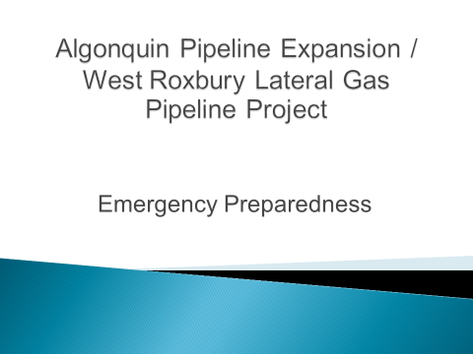

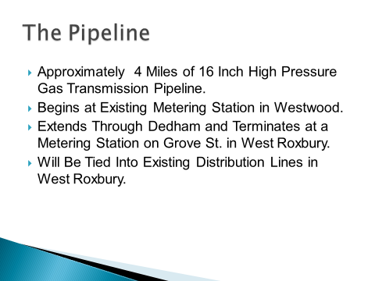

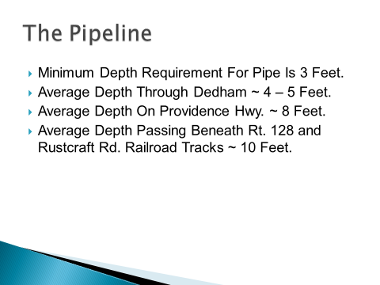

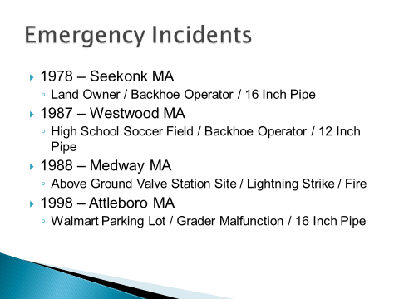

Chief Spillane stated that three of the four incidents were as a result of operator error. Chief Spillane added that they were informed that nationwide the biggest issue that they have, causing these incidents, is done by backhoe. Chief Spillane went on to explain each of these incidents in more detail.

Mr. Kern stated that a few things that the gentleman mentioned were that these incidents all happened on older pipes and he has not had any issues with the newer pipes. Mr. Kern informed all that there is also a new feature used on the newer pipes that has been described as a yellow membrane or plastic sheeting that helps protect the pipes.

Chief Spillane added that he was informed that none of these precautionary measures were in place back in the day when these accidents happened in the pipes were older to begin with. Chief Spillane showed an example of the plastic sheeting and explained how it is installed in the ground.



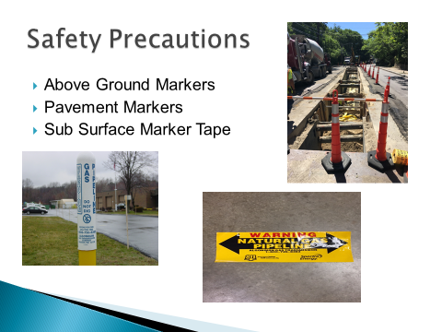

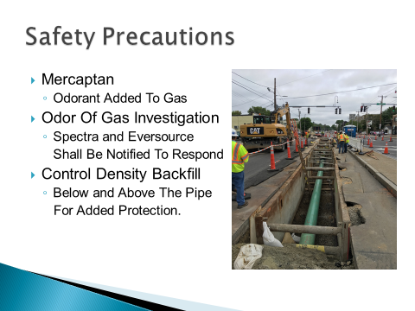

Chief Spillane informed all that anytime the Dedham Fire Department is alerted of a possible gas leak, they would respond as normal, with metering devices monitoring all the storm drains and if there are any concerns both federal and local agencies will be informed and will respond.

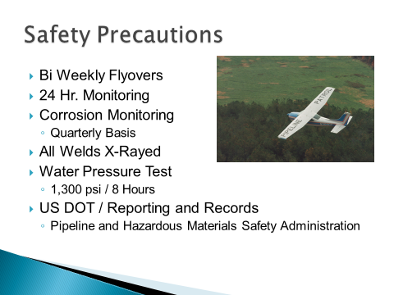

Chief Spillane informed all that the monitoring facility is actually based out of Texas, 24 hours a day, and 365 days a year.

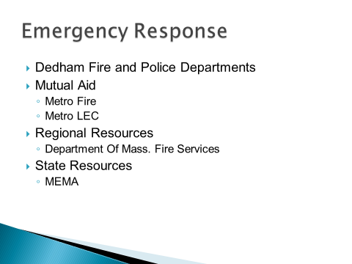

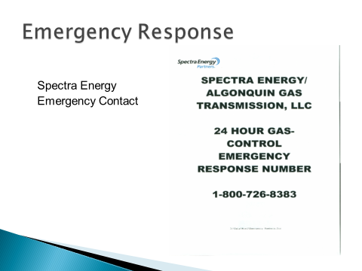

Chief Spillane informed all that the number is monitored 24 hours a day. Chief Spillane added that many members of the Spectra Response Team live within 20 to 30 miles of the pipeline. Chief Spillane continued, saying that it would definitely be under an hour response time but potentially they could be on scene within a half an hour.

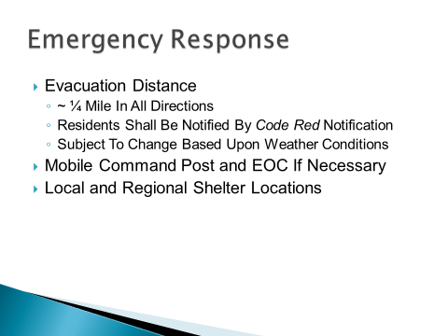

Chief Spillane informed all that the evacuation distance of a quarter-mile is kind of the standard, but that can fluctuate and depends on the weather conditions.

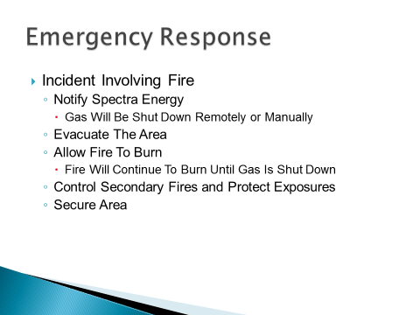

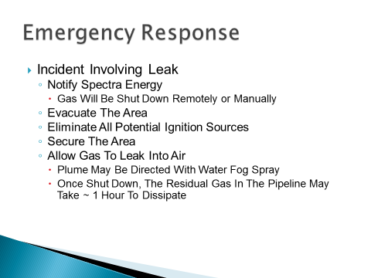

Mr. Guilfoyle asked Chief Spillane the fire was involved in the emergency incidents besides the lightning strike.

Chief Spillane responded no, it was just a lightning fire.

Mr. Guilfoyle asked Chief Spillane, if we call in a gas leak will Spectra shut it down remotely before they respond manually.

Chief Spillane informed all that they will first confirm that it is their pipeline. Once they have done that they will remotely shut it down at both ends. Chief Spillane added that the local officials for Spectra will respond as well.

Mr. MacDonald stated that his concern is Dedham and monitoring the pipeline today and what are the plans for now. Mr. MacDonald asked Chief Spillane if he was planning to have a tabletop exercise.

Chief Spillane responded absolutely. Chief Spillane informed all that one of the questions he asked in the meeting was if Spectra would be willing to participate in a tabletop exercise. They responded, yes.

Mr. MacDonald asked Chief Spillane how people would get evacuated.

Chief Spillane responded that it is not an easy task but they have plans for it. Chief Spillane added that Dedham would rely on the mutual aid communities and the regional forces. Chief Spillane informed all that in regards to a large incident they would divide the area into sections and split the help by using the resources you have. Chief Spillane added that they would have a Code Red call go out to the residents. Chief Spillane asked Mr. Kern if they were still planning on doing a mailing.

Mr. Kern stated that they would like to do that, but they want to be careful to not startle people that are not as informed as others.

Mr. MacDonald stated that when you do a tabletop exercise some of the issues that you think you have don't play out. Mr. MacDonald added that if you have a quarter-mile effectuation you will need the help of the MBTA. Mr. MacDonald informed all that a tabletop exercise is working through all of the scenarios around the table to see what works and what doesn't work.

Mr. MacDonald stated that in speaking with others, the biggest concern is the errant backhoe. Mr. MacDonald asked Mr. Flanagan if there was a way to make it a requirement that Spectra send a representative down any time work involves opening a street.

Mr. Flanagan stated that he is looking to change the format of the permit. Mr. Flanagan added that Spectra will come out as soon as Dig Safe is called. Mr. Flanagan informed all that some of the excavation will require the use of a vacuum not a backhoe.

Mr. MacDonald asked what that was.

Mr. Flanagan informed all that it is a vac truck that is used for vacuum excavation and this is most likely what will be used on East Street.

Mr. Keogh asked how close the Spectra personnel are to the pipeline that runs through Dedham, and what is their ETA.

Chief Spillane informed all that the standard answer is under an hour and they have people living as close as Walpole. Chief Spillane added that when the Spectra personnel are on duty, they are in Westwood.

Dr. Teehan stated that we are on the verge of the day that many of us hoped we would never see, which is the fact that there is actually going to be gas flowing through this pipeline. Dr. Teehan added that he had always held out hope that common sense would prevail but unfortunately it didn't. Dr. Teehan asked Chief Spillane how fast the gas shutoff remotely.

Chief Spillane responded as soon as they touch it. Chief Spillane added that once Spectra receives a call from us, it is a matter of them flipping the switches and it shuts off. Chief Spillane informed all that with 4 miles of pipe will still have fuel and it. Chief Spillane continued, saying that what an important thing to recognize that shutoff valves is that first responders are not allowed to touch the shutoff valves. Chief Spillane stated that as it stands right now there is a shutoff in Westwood at the metering station and one in West Roxbury.

Dr. Teehan stated that this pipeline will be around for 100 years and has to be a part of how we train our first responders in Dedham for generations to come. Dr. Teehan reminded all that there is still litigation pending there still waiting to hear the result. Dr. Teehan continued, saying that this is a very disturbing situation and he is hoping that all the safety precautions work over the long haul but we cannot hope we have to be prepared and we have to be prepared forever.

Chief Spillane informed all that Spectra is required, on an annual basis, to provide training for all first responders within any community that the pipeline goes through. Chief Spillane added that they will have annual meetings and training sessions, with Spectra as well in addition to other exercises like the tabletop.

Dr. Teehan stated all the safety precautions are great but an actual real practice it's not going to be simple. Dr. Teehan thanked Chief Spillane for his efforts, but is hopeful that at some point some common sense will interject into the situation.

Mr. Guilfoyle asked Chief Spillane if the quarter-mile evacuations will be broken down and clearly stated so when other safety personnel come in to aid they know what they're doing.

Chief Spillane informed all that that is very important part of the plan to look at because depending upon where it is the plan could vary.

Michael Cocci, Walnut Street made the following statements.

Dr. Cocci thanked Chief Spillane for the information he provided and stated that he has some ongoing concerns regarding some of the information he heard this evening. Dr. Cocci added that he was surprised to hear the assessment of the meeting Chief Spillane had with Spectra as he has read accounts from other officials that indicated Spectra personnel appeared woefully underprepared and ill-informed about emergency preparedness in our local area. Dr. Cocci stated that this report highlights four emergency incidents, but Spectra is currently under investigation by PIMSA for an incident that happened in April, 2016 with a Spectra owned and operated pipeline in Salem Township, Pennsylvania, that exploded. Dr. Cocci continued, saying that this was a high transmission pipeline like the one in Dedham. Dr. Cocci informed all that the explosion left a 12 foot crater, scorched 40 acres and left one man with third-degree burns over a large percentage of his body. Dr. Cocci stated that preliminary reports indicate corrosion as a culprit, despite having been apparently inspected and 2005 and 2012 with no results on those inspections. Dr. Cocci stated that it's very troubling to him to have that knowledge and then have a presentation from Spectra that says that for incidences and related to backhoe problems.

Mr. Guilfoyle stated that the emergency incidents were based on this particular gentleman's 40 year career in Massachusetts.

Chief Spillane stated that is correct. This report highlighted regional incidences and they are aware of the incident in Pennsylvania. Chief Spillane added that the Spectra representative was not trying to avoid discussing the Pennsylvania incident and it did come up at the meeting.

Mr. Kern stated that this was us asking the Spectra rep how many incidents have they had in this area and added that they weren't trying to represent that this is all that has happened with Spectra.

Dr. Cocci stated that in terms of the annual trainings that Spectra has said they're willing to provide for Dedham, given that their aim is to have gas flowing November 1, are there plans to do this training urgently, scrambling to get this done for the gas flows.

Dr. Cocci asked if it was really the assessment of emergency preparedness folks, who have expertise in this in our Town and the city of Boston that we are adequately prepared for something of this magnitude that we have actually never seen.

Dr. Cocci stated that Spectra has said they're going to come and investigate every potential concern for a gas leak. If someone calls or smells and odor and notifies safety personnel how are they going to manage that.

Chief Spillane informed Dr. Cocci that he did not mean they were going to come out on every single gas leak. Chief Spillane added that if a resident calls, saying they smell an odor of gas the fire department does its normal response and the voters along the pipeline route, we can determine the cause. It may be an Eversource leak that we can identify and take care of. This would not require the presence of Spector. Chief Spillane added that if we were out along the route of the pipeline and there is a strong odor, from where the catch basins or what have you, we have no way to identify it by just the odor, then both agencies would respond.

Dr. Cocci stated that regarding the evacuation process we should probably acknowledge that within the incineration zone there will be an inability to evacuate residents that are right within that area. Dr. Cocci asked if that was a fair assessment.

Chief Spillane stated that that is probably fair to say and added that she had a major fire type incident, there is a fair expectation that there will be casualties.

Mr. MacDonald asked Dr. Cocci, as far as notification, what is his sense is of what should or shouldn't go out to the residents.

Dr. Cocci stated that he definitely appreciates the concern about not causing panic but he thinks that the fact the room is fairly empty here shows the residents of the Town don't necessarily have a full appreciation of what is actually happening or about to happen. Dr. Cocci added that he agrees that there needs to be some sort of communication so that there is a better awareness of the potential threat, even though it may be rare, it is a real possibility and it has happened all over the country, there's no reason to suspect that it wouldn't or couldn't happen here. Dr. Cocci continued, saying that he's not sure what kind of materials this would include. Dr. Cocci stated that he does think there should be some indication with the residents about what the evacuation process may look like, who to call, etc.

Dr. Teehan asked if there should be detailed evacuation plans made out for every part of the route.

Mr. MacDonald stated that he believes we can have evacuation routes, but we cannot have specifics because of the variables that could be involved. Mr. MacDonald added that we should leave the details to the incident commanders.

Mr. Kern stated that in these cases wind is a big deal. Mr. Kern added that the incident commander needs to be able to make a decision and maybe rush-hour or there is construction on a particular route. Decisions like that need to be made on the scene.

Mr. Kern asked, do we feel we're prepared for this, something that has never happened here. As Chief Spillane will tell you, he does not get to design the risk he has to try to respond to it. This is true whether it is anthrax, a plane crash, etc. Mr. Kern added that they're going to continue to work this problem.

Dr. Cocci stated that he didn't mean that all of the risks and problems can actually be anticipated. He added that his point is a 750 PSI pipeline through our Town is a little bit of a different risk and he asked that we continue to push Spectra and our elected leaders and potentially reach out to Boston to figure out whether additional discussions need to be held.

Mr. Guilfoyle stated that. Chief Spillane is working on this for multiple days, dealing with individuals on getting answers to these questions.

Dr. Teehan stated that he believes we need to have an update on this at some point, in open session, sometime after November 1 when we have more detail of what's going on with the plans and our preparedness. Dr. Teehan stated that he believes this is important.

Mr. Butler moved to adjourn the meeting; seconded by Mr. Keogh. **On the Vote:** Mr. Keogh, yes; Dr. Teehan, yes; Mr. Butler, yes; Mr. Guilfoyle, yes; Mr. MacDonald, yes.

The meeting was adjourned at 8:44 pm.

The next meeting is scheduled for Thursday, October 27, 2016 at 7p.m. This is to certify that the above is a true and accurate record of the Minutes of the Board of Selectmen’s Meeting held on October 13, 2016, which minutes were approved on October 27, 2016.

________________________

Dennis Guilfoyle – Chairman