A Meeting of the Board of Selectmen was held on Thursday July 18, 2019, 6:30 pm, in the Francis O’Brien Meeting Room, Town Hall, 26 Bryant Street, Dedham, Massachusetts

Present were:

Dennis J. Guilfoyle - Chair

Dr. Dennis J. Teehan - Vice Chair

James A. MacDonald

Sarah E. MacDonald

Dimitria Sullivan

Mr. Guilfoyle called the Meeting to order at 7:02 pm

**Pledge of Allegiance**

Led by Mr. Guilfoyle

**Dedham Citizens – Open Discussion**

**Presentation/Discussion w/ Dedham Substance Abuse Coalition**

Mike Butler, former member of the Board of Selectmen, introduced Kristina King, Program Director - Drug Free Communities Grant.

Mr. Butler reminded all that about a year ago, the Town received a 5-year $625,000 grant, with an option for another 5 years, thanks in no small part to Dedham’s Public Health Nurse, Jessica Tracey. Mr. Butler informed all that this grant allowed the Town to hire Ms. King. Mr. Butler spoke about Ms. King’s work experience.

Ms. King went through the following Power Pont Presentation:

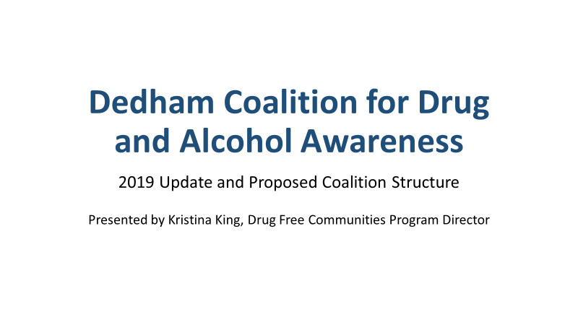

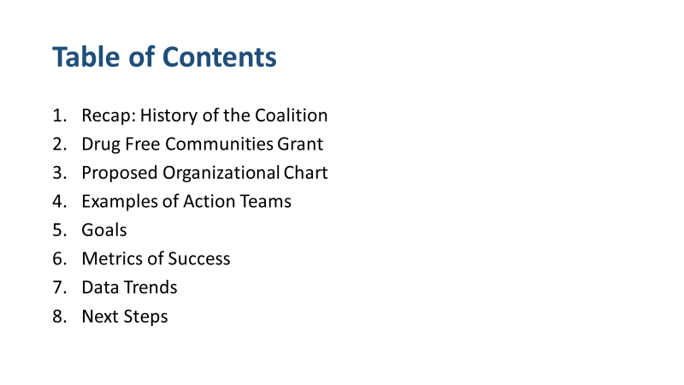

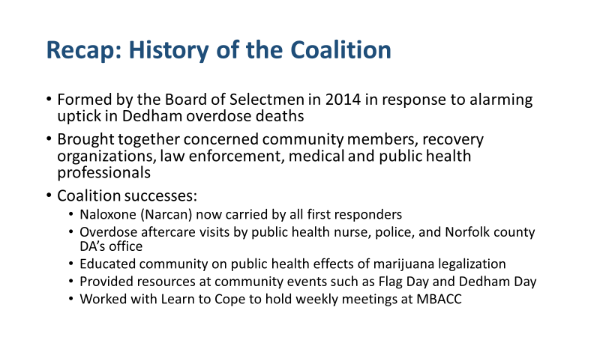

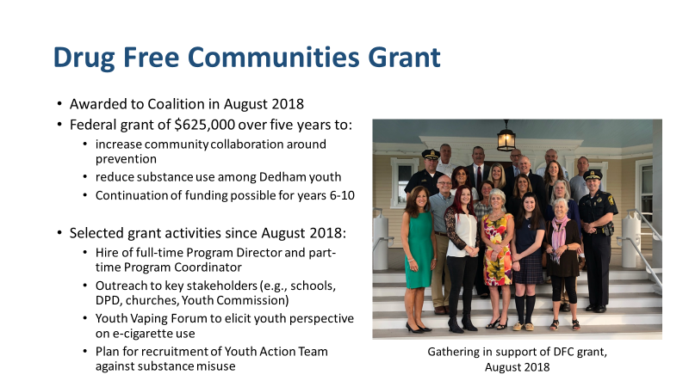

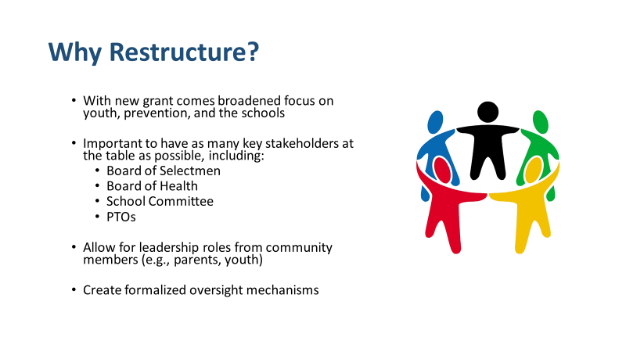

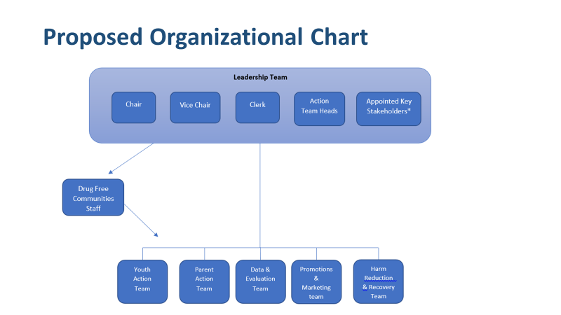

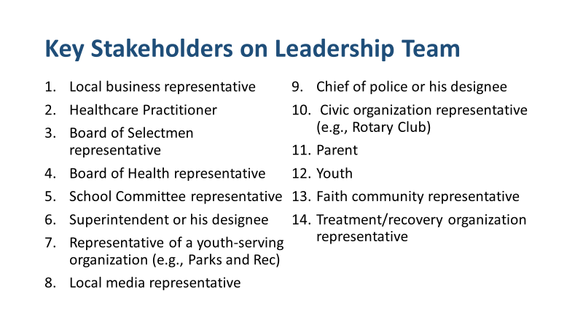

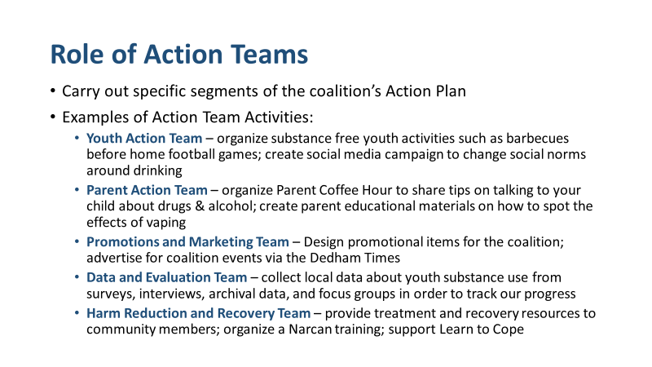

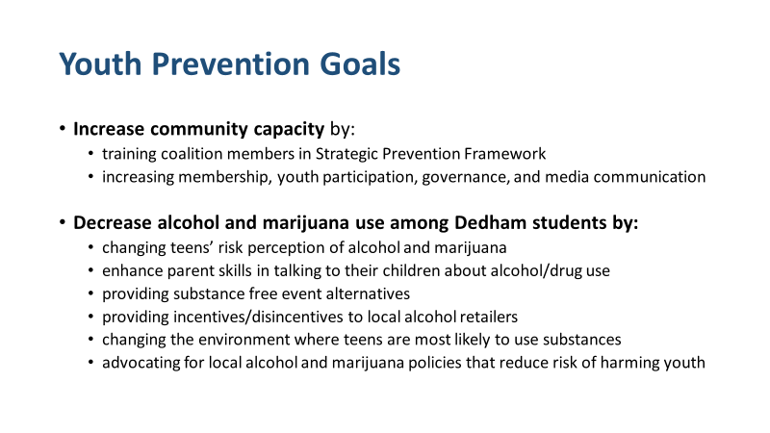

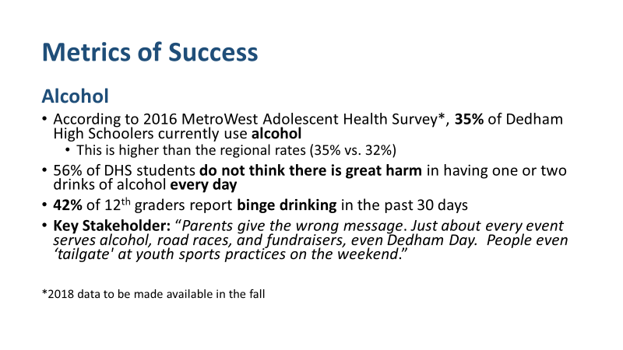

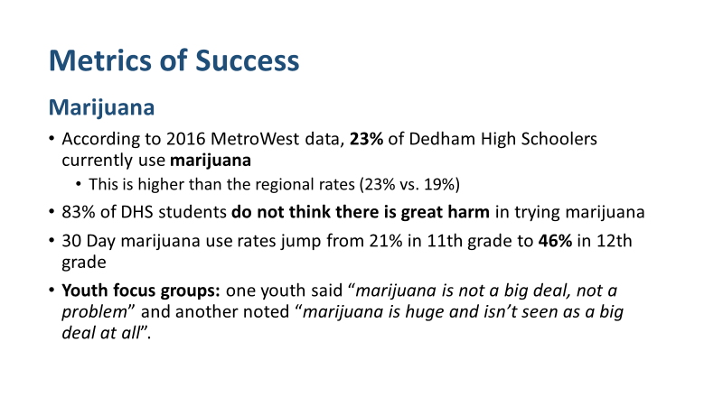

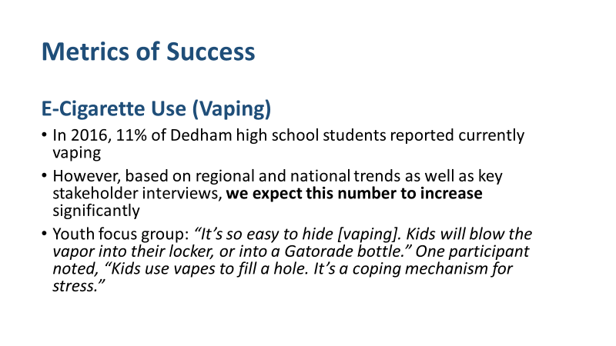

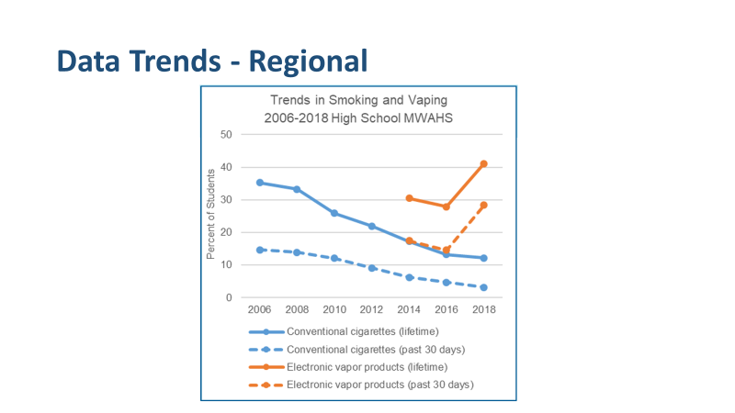

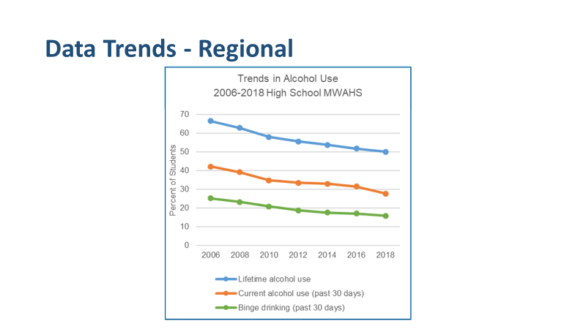

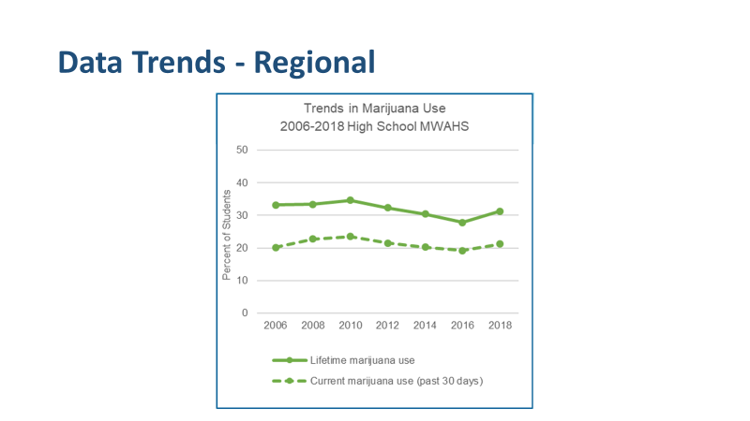

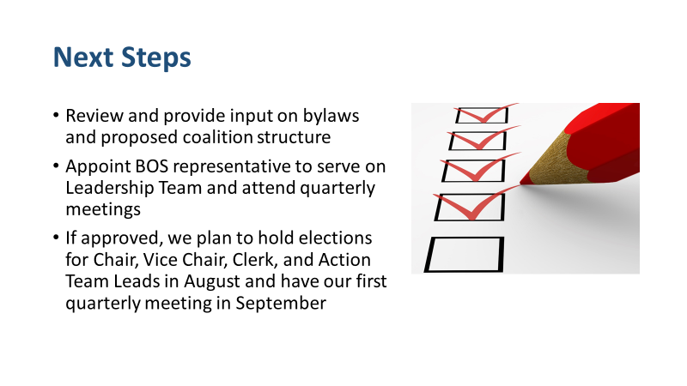

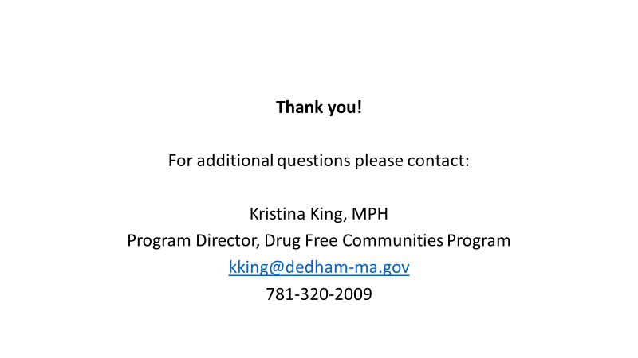

Dr. Teehan stated that he would be happy to serve as the Board Member on the Coalition. Dr. Teehan spoke about some of the alcohol and drug abuse he is seen in his patients and hopes the treatment will be easier to get than it is now.

Ms. MacDonald stated that it is very clear that kids need to hear from other kids and not older residents. Ms. McDonald asked Ms. King how she plans on building the peer to peer relationships.

Ms. King suggested using the 84 method, which is a Massachusetts movement, for the 84% of youth who hopefully put together youth active do not use tobacco products into organizing and advocating at the Local and State level. Ms. King added that she and her colleagues have met with the Youth Commission to put together a Youth Action Team. Ms. King continued, saying that they also went to the College-Bound Program to give a presentation on the signs of vaping.

Ms. Sullivan asked Ms. King if she had any intention of surveying the Middle School students.

Ms. King answered yes.

Mr. MacDonald stated that he would like to have Ms. King back at a meeting when she has the 2018 data. Mr. MacDonald then spoke about how young kids think that engaging in these bad habits is no big deal but when you look at the statistics, it is a big deal.

Mr. Guilfoyle asked Ms. King if the surveys focus more on the edibles and vaping.

Ms. King answered and she doesn’t think the surveys break it down like that but going forward that could be very useful.

Dr. Teehan stated that the science is going one way and the message is going the other way we must unify the thinking and treatment regarding what is happening. Dr. Teehan added that we have to give a clear and concise message regarding regulating the sale of marijuana.

**Discussion & Vote Re: Appointment to Dedham Retirement Board**

Ms. Baker stated that the Board was notified of the resignation of longtime Retirement Board member John Fontaine. Ms. Baker added that a notice was posted on June 25, with an application deadline of July 9, 2019. Ms. Baker informed all that Mr. Butler applied within the timeframe and is the only applicant in front of the Board for consideration. Ms. Baker continued, saying that it is a three-year term expiring in June 2022.

Mr. MacDonald moved approval of Michael Butler as the Board of Selectmen’s designee to the Retirement Board; seconded by Dr. Teehan. **On the Vote**: Ms. MacDonald, yes; Dr. Teehan, yes; Ms. Sullivan, yes; Mr. Guilfoyle, yes; Mr. MacDonald, yes.

Dr. Teehan stated that this is not an easy task, but it is a necessary one. Dr. Teehan thanked Mr. Butler for his service to the Town.

Mr. Guilfoyle stated his thanks to Mr. Fontaine for his service to the Retirement Board of Dedham.

**Discussion & Vote Re: Disposition of Compliance Failure Violation Hearings for: A.C.B.E., Inc. d/b/a Auld Sod Pub, 274 Washington St.; and PM Entertainment Group, d/b/a Dedham Community Theatre, 580 High Street**

**AULD SOD PUB – FINDING(S)**

Mr. MacDonald moved to find that the licensee, A..C.B.E INC., d/b/a Auld Sod Pub 274 Washington Street, did violate Massachusetts General Laws Chapter 138, Section 34 and the Town of Dedham’s Rules & Regulations [sale or delivery of alcohol to a person under 21 years of age], 204 CMR 2.05 (2) [permitting any disorder, disturbance or illegality of any kind to take place in or on the licensed premises], and/or the rules and regulations for holders of Alcoholic Beverage Licenses in the Town of Dedham, #23 [sale or delivery to a person under 21 years of age] as outlined in the April 11, 2019 Police Report; seconded by Ms. Sullivan. **On the Vote:** Ms. MacDonald, yes, Dr. Teehan, yes, Ms. Sullivan. Yes, Mr. Guilfoyle, yes, Mr. MacDonald, yes.

**AULD SOD PUB – SANCTION(S)**

Mr. MacDonald moved that a written warning be issued regarding the all alcohol restaurant license issued to A.C.B. E. INC., d/b/a Auld Sod Pub 274 Washington Street; seconded by Mr. Guilfoyle. **On the Vote:** Ms. MacDonald, yes, Dr. Teehan, yes, Ms. Sullivan. Yes, Mr. Guilfoyle, yes, Mr. MacDonald, yes.

Mr. MacDonald stated that this is the first violation in quite some time for the Auld Sod Pub.

**DEDHAM COMMUNITY THEATRE – FINDING(S)**

Mr. MacDonald moved to find that the licensee, PM Entertainment Group, d/b/a Dedham Community Theatre, 580 High Street did violate Massachusetts General Laws Chapter 138, Section 34 and the Town of Dedham’s Rules & Regulations [sale or delivery of alcohol to a person under 21 years of age], 204 CMR 2.05 (2) [permitting any disorder, disturbance or illegality of any kind to take place in or on the licensed premises], and/or the Rules and Regulations for holders of Alcoholic Beverage Licenses in the Town of Dedham, #23 [sale or delivery to a person under 21 years of age] as outlined in the April 11, 2019 Police Report; seconded by Ms. MacDonald.

Ms. MacDonald stated that the Board received a letter from the former Manager of the Dedham Community Theatre, Karen Parrelli,

**On the Vote:** Ms. MacDonald, yes, Dr. Teehan, yes, Ms. Sullivan. Yes, Mr. Guilfoyle, yes, Mr. MacDonald, yes.

**DEDHAM COMMUNITY THEATRE – SANCTION(S)**

Mr. MacDonald moved that a written warning be issued regarding the all alcohol restaurant license issued to PM Entertainment Group, d/b/a Dedham Community Theatre, 580 High Street; seconded by Ms. MacDonald. **On the Vote:** Ms. MacDonald, yes, Dr. Teehan, yes, Ms. Sullivan. Yes, Mr. Guilfoyle, yes, Mr. MacDonald, yes.

Following is a statement by Ms. Karen Parrelli, former Manager of the Dedham Community Theatre, that she wished would be entered into the record.

My name is Karen Parrelli, I was the Manager of the Dedham Community Theatre for nine years. I was dismissed on May 20, 2019. At the June 20 Board of Selectmen’s Meeting regarding the alcohol violation at the Theatre, a statement was made by Attorney John Gibbons representing the Theatre that was inaccurate and I would like to correct it and share what happened.

On the evening of the violation, the movie started at 7 PM and Clarissa Robyn and I were waiting for a 9 PM event. At 8 PM, an hour after the movie started, I went up to the office to do some work. A short time later Clarissa came up to the office and said she had neglected to check an ID and that there was an officer downstairs who wanted to speak with me. I went downstairs to the lobby and provided all information he requested.

This was the first and only offense of this kind under my nine years of managing of the Theatre.

I fully understand that all employees need to be TIPS certified. New hires are given a 45-day window after their start date in order to get certified. The employee in question, Clarissa Robyn was within that 45-day window and so the Theatre was following the TIPS certification requirement at that time.

I took this very seriously and over the next week I met with Sgt. Clements and read over all the material he left with me and posted the free TIPS training seminar flyer in the box office. I discussed with staff members the importance of checking IDs and going through the TIPS training program I scheduled one staff member to take the free TIPS training seminar being offered on May 3 at the American Legion and helped another get trained online. I also posted a sign in the box office at the entrance of the concession stand there read large print “to be served alcohol, customers must be born before today’s date 1998”. All servers must be TIPS certified. See me for more information.

On May 20, six weeks after the violation, Paul McMurtry, the owner of the Theatre, took me to dinner and told me that he would be spending less time at the Statehouse and would be taking over managing the Theatre, so I was no longer needed. He said he wanted me to still represent the Theatre at the Board of Selectmen’s Meeting for the alcohol violation and expressly told me that it was not because of the violation that he decided to take over managing the Theatre.

Clarissa Robyn, the employee on duty at the time, was also not terminated for the alcohol violation, but left on her own accord at the end of April to go to St. Louis to earn her Masters.

I understand that I was the Manager on duty at the time of the violation, but I would like the record corrected as being terminated for the alcohol violation.

I grew up in Dedham and have worked in this community for many years and my family still lives here. This tarnishes my name and reputation as a dedicated and loyal Manager and may hinder my ability to get employment. I would appreciate it if the record would be corrected.

End of statement.

**Public Hearing Re: Transfer of All Alcoholic Package Store License from KH&H Liquors, Inc., 200 Legacy Boulevard, Dedham to Costco Atlantic Liquors, Inc., 200 Legacy Boulevard, Dedham**

Corey Wilk, Goulston & Storrs, Counsellor at Law, Counsel to Costco Atlantic Liquors, was present before the Board. Mr. Wilk introduced TJ Cleary, the proposed Manager of Record.

Ms. MacDonald stated that right now KH&H is outside of Costco.

Mr. Wilk stated yes.

Ms. MacDonald asked if it would remain a separate entity.

Mr. Wilk stated no, the plan is to open that door up, license the store and have the liquor in a portion of the store.

Mr. Guilfoyle asked Mr. Wilk if the liquor would be in one Section of the store and not spread out.

Mr. Wilk answered that the plan was to have one Section initially. Mr. Wilk described how they would place liquor strategically with food around the store.

Discussions took place regarding what Costco Atlantic liquors would have to do to license the whole store or to display alcohol in different Sections of the store.

Ms. MacDonald asked Mr. Wilk to show them, on the floor plans, the Sections of the store he is talking about licensing and displaying in.

Dr. Teehan stated that he does not feel that the Board needs to restrict them to one area.

Ms. MacDonald moved approval, of the area to be licensed, as presented; seconded by Ms. Sullivan. **On the Vote:** Ms. MacDonald, yes, Dr. Teehan, yes, Ms. Sullivan. Yes, Mr. Guilfoyle, yes, Mr. MacDonald, yes.

Mr. MacDonald asked Mr. Wilk who will be the Manager of Record.

Mr. Wilk stated that Mr. TJ Cleary will be the Manager of Record.

Mr. Cleary informed the Board that he’s been with Costco for 23 years and has been a Manager for 16 years. Mr. Cleary added that he has just taken over the Dedham Costco location as the General Manager.

Mr. Guilfoyle asked Mr. Cleary if he had previously been a Manager of Record.

Mr. Cleary answered no.

Mr. MacDonald asked Mr. Cleary to explain the process at Costco at the point-of-sale.

Mr. Cleary answered that they card anyone who looks under the age of 40. Mr. Cleary added that once alcohol is scanned in, the process stops until somebody can be properly carded. Mr. Cleary continued, saying that other employees are constantly monitoring the POS and self-checkout lanes.

Mr. MacDonald asked Mr. Cleary what training Costco requires for employees who deal with alcohol sales.

Mr. Wilk informed all that any employee who deals with the sale of alcohol is TIPS certified.

Mr. MacDonald suggested that Mr. Wilk and Mr. Cleary get in touch with Sgt. Clements, the alcohol officer for Dedham to set up a time for them to speak and go over the rules and regulations.

Mr. MacDonald moved approval of TJ Cleary as the Manager of Record at Costco Atlantic Liquors; seconded by Dr. Teehan. **On the Vote:** Ms. MacDonald, yes, Dr. Teehan, yes, Ms. Sullivan. Yes, Mr. Guilfoyle, yes, Mr. MacDonald, yes.

**Discussion & Vote Re: Amendment to Traffic Regulations Re: Louise Road**

Ms. Baker informed the Board that some time ago they approved improvements McDonald Square sidewalk area. Ms. Baker added that those improvements are underway and she believes may be complete. Ms. Baker continued, saying that as a result, the Engineering Department has submitted a request for the Board to amend part one, schedule one of the Traffic Rules and Regulations to adopt a no parking any time restriction on the westerly side of Louise Road from Hooper to Bonham.

Ms. MacDonald moved approval of the amendment; seconded by Mr. MacDonald. **On the Vote:** Ms. MacDonald, yes, Dr. Teehan, yes, Ms. Sullivan. Yes, Mr. Guilfoyle, yes, Mr. MacDonald, yes.

**Violation Hearing – Compliance Failure Re: High Street Dining, Inc. d/b/a Centre Deli/Market and Deli After Dark, 545 High St., Ziad Griege, Manager**

Ziad Griege, Owner, was present before the Board.

Ms. Baker swore in those who would be giving testimony.

Sgt. Clements summarized Detective Quigley’s report from April 11, 2019.

Mr. Guilfoyle asked Mr. Griege if he waves the reading of the entire report.

Mr. Griege answered yes

Mr. Griege informed the Board that all employees are TIPS certified and they are constantly talking about checking IDs. Mr. Griege added that he is very sorry that he is again in this situation.

Mr. MacDonald suggested that Mr. Griege use the Fenway Park rule, which is carding everybody.

Mr. Guilfoyle and Dr. Teehan gave Mr. Griege suggestions on how to not end up in this situation again.

Mr. Guilfoyle asked Sgt. Clements if he had a follow-up statement.

Sgt. Clements informed all that Mr. Griege had all the paperwork up to date.

Mr. MacDonald moved to close the hearing; seconded by Dr. Teehan.

Mr. Guilfoyle asked Mr. Griege if he had a fair hearing.

Mr. Griege answered yes.

**On the Vote:** Ms. MacDonald, yes, Dr. Teehan, yes, Ms. Sullivan. Yes, Mr. Guilfoyle, yes, Mr. MacDonald, yes.

Mr. MacDonald moved that the Board deliberate and decide the disposition at our next meeting; seconded by Ms. Sullivan. **On the Vote:** Ms. MacDonald, yes, Dr. Teehan, yes, Ms. Sullivan. Yes, Mr. Guilfoyle, yes, Mr. MacDonald, yes.

**Violation Hearing – Compliance Failure Re: Shake Shack Legacy Place Dedham LLC d/b/a Shake Shack, 226 Legacy Pl., Michael David Tobins, Manager**

Atty. Andrew Upton and Manager LC Cotton were present before the Board.

Ms. Baker swore in those who would be giving testimony.

Sgt. Clements summarized Ofc. Marissa Holland’s report from April 11, 2019.

Mr. Guilfoyle asked Attorney Upton if he would like to have the entire Police record read.

Attorney Upton stated that they wave their right to the reading.

Mr. MacDonald stated that he would like to hear from either Attorney Upton or LC Cotton, Manager.

Attorney Upton informed the Board that he will give a general overview and then will turn it over to Mr. Cotton.

Attorney Upton stated that it was a busy night and the server did check the ID but did the math wrong. Attorney Upton informed the Board that they developed the Alcohol Beverage Server Awareness form, to supplement existing training and on Boarding. Attorney Upton explained what this form consists of.

Mr. Cotton stated that they have pictures of correct IDs, horizontal IDs in the correct year, in the cash wrap area where all servers will see them. Mr. Cotton added that within the POS system, a button pops up asking if you have carded the patron, then yet another button pops up asking the patron was over or under 21 years of age.

Ms. MacDonald asked if Mr. Cotton was the Manager of Record when the violation occurred.

Attorney Upton clarified that Mr. Cotton is not the Manager of Record and informed the Board that William Spofford was transferred to their location around three weeks ago and the restaurant will be filing the proper paperwork for a change of Manager to Mr. Cotton.

Sgt. Clements stated that the Shake Shack is unique in its operations. Sgt. Clements added that he met with Brian McGowan on April 23, 2019 and he was not able to supply any employment records.

Mr. Guilfoyle asked Ms. Baker, if Shake Shack had any alcohol-related incidents in the past.

Ms. Baker responded no.

Mr. Guilfoyle asked Attorney Upton if he had a fair hearing.

Mr. Upton asked a few questions first. Mr. Upton asked Sgt. Clements if the Police used the ABCC guidelines guide their compliance checks.

Sgt. Clements answered that there based on ABCC guidelines.

Mr. Upton confirmed that he had a fair hearing.

Mr. MacDonald moved to close Public hearing; seconded by Ms. MacDonald. **On the Vote:** Ms. MacDonald, yes, Dr. Teehan, yes, Ms. Sullivan. Yes, Mr. Guilfoyle, yes, Mr. MacDonald, yes.

Mr. MacDonald moved that the Selectmen decide disposition at the next meeting; seconded by Ms. Sullivan. **On the Vote:** Ms. MacDonald, yes, Dr. Teehan, yes, Ms. Sullivan. Yes, Mr. Guilfoyle, yes, Mr. MacDonald, yes.

Mr. MacDonald moved to close the Public Hearing; seconded by Ms. MacDonald. **On the Vote:** Ms. MacDonald, yes, Dr. Teehan, yes, Ms. Sullivan. Yes, Mr. Guilfoyle, yes, Mr. MacDonald, yes.

Mr. MacDonald moved that the Board decide disposition at their next meeting; seconded by him Ms. Sullivan. **On the Vote:** Ms. MacDonald, yes, Dr. Teehan, yes, Ms. Sullivan. Yes, Mr. Guilfoyle, yes, Mr. MacDonald, yes.

**Discussion & Vote Re: Approval of Select Board legislation**

Ms. Baker informed all that the Board received a communication from Rep. McMurtry’s office and attached to that communication is a memo from House Counsel which reflects, in the areas of the Town Charter, where the words Board of Selectmen will be replaced with Select Board.

Mr. MacDonald moved that the Board concur with House Counsel’s recommendation to replace Board of Selectmen with Select Board in the Town Charter; seconded by Ms. MacDonald. **On the Vote:** Ms. MacDonald, yes, Dr. Teehan, yes, Ms. Sullivan. Yes, Mr. Guilfoyle, yes, Mr. MacDonald, yes.

**Violation Hearing – Compliance Failure Re: The Dedham Midway Corp. d/b/a The Midway Steakhouse, 269 Washington St., Robert A. Jenks, Jr., Manager**

Robert and Donna Jenks were present before the Board.

Ms. Baker swore in those would be giving testimony.

Sgt. Clements summarized the Police Report written by Detective Quigley Re: Thursday, April 11, 2019.

Mr. Guilfoyle asked Mr. Jenks if you like to wave the reading of the full report. Mr. Jenks answered yes.

Mr. Jenks informed all that the Midway has been in the Town since 1949. Mr. Jenks added that he deeply regrets what has happened and he will work very hard to make sure it doesn’t happen again. Mr. Jenks continued, saying that he and his wife Donna have implemented some changes and have the staff re-certified in TIPS. Mr. Jenks stated that they also installed a born-on date clock. Mr. Jenks added that there looking into an app that will verify IDs.

Mr. MacDonald informed Mr. Jenks that there is a good app from the State of Iowa, that is free.

Mr. Guilfoyle asked Ms. Baker if the Midway had any previous violations.

Ms. Baker answered no.

Mr. MacDonald moved to close the public hearing; seconded by Dr. Teehan. **On the Vote:** Ms. MacDonald, yes, Dr. Teehan, yes, Ms. Sullivan. Yes, Mr. Guilfoyle, yes, Mr. MacDonald, yes.

Mr. Guilfoyle asked Mr. Jenks if he feels that he had a fair hearing.

Mr. Jenks answered yes

Mr. MacDonald moved that the Board decide disposition at their next meeting; seconded by Dr. Teehan. **On the Vote:** Ms. MacDonald, yes, Dr. Teehan, yes, Ms. Sullivan. Yes, Mr. Guilfoyle, yes, Mr. MacDonald, yes.

**Violation Hearing – Compliance Failure Re: Halfway Café, Inc. d/b/a Halfway Café, 174 Washington St., Nikki David, Manager**

John Grasso, proprietor of the Halfway Café, was present before the Board.

Ms. Baker swore in those that will be giving testimony.

Sgt. Clements summarized Detective Quigley’s report regarding the compliance failure on April 11, 2019.

Mr. Guilfoyle asked Mr. Grasso if he would like to wave the reading of the full report.

Mr. Grasso answered yes.

Mr. Grasso informed all that they have been in the Town of Dedham almost 29 years and for the first 28 years we were never before this Board. Mr. Grasso added that this is their second compliance failure in the last year and he feels humiliated.

Mr. Grasso stated that he is very sorry this incident occurred, and he is trying to work with his employees to make sure it never happens again.

Sgt. Clements informed the Board that when he followed up with the Halfway Café, they were very organized, and he supplied the paperwork upon request showing that all employees are up to date with their TIPS certification.

Mr. Guilfoyle asked Mr. Grasso for feels the other fair hearing.

Mr. Grasso answered yes.

Mr. MacDonald moved to close the public hearing; seconded by Dr. Teehan. **On the Vote:** Ms. MacDonald, yes, Dr. Teehan, yes, Ms. Sullivan. Yes, Mr. Guilfoyle, yes, Mr. MacDonald, yes.

Mr. MacDonald moved that the Board decide disposition at its next meeting; seconded by Ms. Sullivan. **On the Vote:** Ms. MacDonald, yes, Dr. Teehan, yes, Ms. Sullivan. Yes, Mr. Guilfoyle, yes, Mr. MacDonald, yes.

Dr. Teehan moved to take an item not on the agenda; seconded by Ms. Sullivan.

**On the Vote:** Ms. MacDonald, yes, Dr. Teehan, yes, Ms. Sullivan. Yes, Mr. Guilfoyle, yes, Mr. MacDonald, yes.

Ms. Baker informed the Board that Virginia LeClair and the folks from Dedham Trails Day, would like permission to hang a banner on the fence in Dedham Square promoting Dedham Trails Day on August 4, 2019.

Ms. MacDonald moved approval; seconded by Dr. Teehan. **On the Vote:** Ms. MacDonald, yes, Dr. Teehan, yes, Ms. Sullivan. Yes, Mr. Guilfoyle, yes, Mr. MacDonald, yes.

**Discussion & Vote Re: Request for DEF Dash 5k (10/6/19)**

Mark Riley, President of the Dedham Education Foundation, was present before the Board. Mr. Riley stated that they are asking the Board’s approval to hold the DEF Dash 5K, on October 6, 2019. Mr. Riley informed the Board that they received Park and Rec’s permission to use Barnes Memorial Field. Mr. Riley added that that is spoken with Police Chief Mike D’Entremont regarding the race route. Mr. Riley continued, saying that he has reached out to all the Boards necessary. Mr. Riley continued, saying that they have contracted Jim D’Entremont to handle all the beer service. Mr. Riley informed the Board that Mr. D’Entremont holds a 12 C license regarding the alcohol service. Mr. Riley stated that there hoping for the Boards permission to hang a banner in Dedham Square promoting the run.

Ms. MacDonald spoke about the importance of notifying residents that may be disrupted during the 5K race and asked Mr. Riley, as an organizer, to help her come up with different ways to notify residents.

Mr. Riley informed the Board that at the last DEF meeting, they spoke about going door-to-door, dropping off information about the run.

Mr. MacDonald moved approval; seconded by Dr. Teehan. **On the Vote:** Ms. MacDonald, yes, Dr. Teehan, yes, Ms. Sullivan. Yes, Mr. Guilfoyle, yes, Mr. MacDonald, yes.

**Remaining Candidate Statements/Discussion & Vote Re: Appointments to Master Plan 2020 and Charter Study Committee**

Mr. Guilfoyle informed all that the Board will not be voting this evening but will vote at its next meeting.

Dieckmann Cogill, Master Plan Committee, was present before the Board. Ms. Cogill informed the Board that she has lived in Dedham for around three years and continued to describe her experience and what skills she would bring to the committee.

Tom Ryan, Charter Study Committee, stated that he is interested in serving on the charter study committee. Mr. Ryan went on to go over his past experiences that would make him a good fit for this committee.

**Town Manager’s Report**

N/A

**Action by BOS**

ESMinutes

11/2/2017, 2/15/2018, 3/8/2018, 9/20/2018

Dr. Teehan Moved approval; seconded by Ms. Sullivan. **On the Vote:** Ms. MacDonald, yes, Dr. Teehan, yes, Ms. Sullivan. Yes, Mr. Guilfoyle, yes, Mr. MacDonald, yes.

­­­­­­­­­­­­­­­

Request for Stop Sign at Madison, Shire Town & Circuit

Dr. Teehan moved to refer the request to Engineering for a recommendation to come back before the Board after completing the necessary studies; seconded by Ms. Sullivan. **On the Vote:** Ms. MacDonald, yes, Dr. Teehan, yes, Ms. Sullivan. Yes, Mr. Guilfoyle, yes, Mr. MacDonald, yes.

**Old/New Business**

Mr. MacDonald stated that he would like to give Abandoned Housing Initiative update as there been many changes since the last one.

Mr. MacDonald spoke about the Blighted Property By-Baw that he submitted to Town Meeting, the Atty. Gen.’s Office has approved with comments. Mr. MacDonald added that, Town Counsel is reviewing it to give direction to the Building Department.

Mr. MacDonald stated that the Dedham Fire Department has been extremely busy with fires in Riverdale, Oakdale and Greenlodge and he wanted to make note of the hard work they’ve been doing and continue doing.

Ms. MacDonald stated that there has been some progress made at the Striar Property. Ms. MacDonald reminded all that about 45 days ago Parks and Recreation gave a 90-day notice to the three contractors. Ms. MacDonald continued, saying that as of our last meeting, Royer Tree Service is completely off the site. Ms. McDonald stated that P Gioioso & Sons Inc. was asked to stop work immediately as of last Tuesday, since they continually worked outside of the hours allowed in the by law. Ms. McDonald continued, saying that RJB, continues to use the site basically as a transfer station.

Ms. MacDonald stated that DPW Director Joe Flanagan, has gone before the Conservation Commission to begin discussions about shrinking the footprint of the site and putting in some additional ferns as well as shrubs, trees etc.

Ms. Baker stated that yesterday morning she, Greg Johnson, Jeremy Rosenberger, John Sisson and Joe Flanagan met with Griffith Properties but it ended up being mostly a discussion regarding Amazon. Ms. Baker added that in the meeting they learned that Amazon will be expanding into the entire building.

A discussion about Amazon trucks, their reckless driving and Town signage took place

Ms. Baker informed all that Amazon Corporate was going to review how their drivers get their directions and report back to her. Ms. Baker stated that the expansion is not expected to be built goes out or complete until next spring but Amazon will continue to in discussions with the Planning Board and the Building Department to find out what they may have to go through as far as a review of the parking plan and the buildout.

A discussion regarding the East St., Rotary train crossing and what they can do to remedy the situation going forward took place.

Ms. MacDonald asked Ms. Baker if we could reach out to Westwood to see what steps were taken to concluded how they fixed problem.

Dr. Teehan thanked the contractor at the Ames Schoolhouse for mowing the lawn Dr. Teehan added that he had a discussion with Jason Mammone Re: Lowder Street which is another problem Street in Dedham. Dr. Teehan continued, saying that it has become a huge cut through Street.

Ms. Sullivan asked for an update on the Town Bus and the budget.

Ms. MacDonald moved that the Board enter Executive Session: Pursuant to M.G.L. Ch.39, Sec. 23B Exemption 3 (potential litigation/Ames) and Exemption 6 (real property/Striar); seconded by Dr. Teehan. **On the Vote**: Ms. MacDonald, yes; Dr. Teehan, yes; Ms. Sullivan, yes; Mr. Guilfoyle, yes; Mr. MacDonald, yes.

Mr. Guilfoyle stated that the Board will exit Executive Session only to adjourn the meeting.

The next Meeting is scheduled for Thursday July 25, 2019. This is to certify that the above is a true and accurate record of the minutes of the Selectmen’s Meeting held on July 18, 2019, which minutes were approved on August 29, 2019.

_________________________

Dennis J. Guilfoyle. – Chairman