A Meeting of the Board of Selectmen was held on Thursday February 28, 2019, 6:30PM, in the Francis O’Brien Meeting Room, 26 Bryant Street, Dedham, Massachusetts

Present were:

James A. MacDonald – Chair

Brendan G. Keogh - Vice Chair

Dr. Dennis J. Teehan Jr.

Michael L. Butler

Dennis J. Guilfoyle

Mr. MacDonald called the Meeting to order at 6:35 pm

**Pledge of Allegiance**

Led by Mr. MacDonald

Mr. MacDonald asked everyone to remain standing for a moment of silence for Bob Aldous, who passed away recently.

**Dedham Citizens Open Discussion**

None.

**Discussion w/ Town Engineer Jason Mammone Re: Private Infiltration Removal**

Mr. Mammone reminded everyone that it was about a year ago that he gave a presentation called moving forward with INI. Mr. Mammone stated that he will be going over the ideas he has going forward. Mr. Mammone added that he will be going into the data that they have uncovered regarding INI and what they have done as a result of discussions we’ve had in the last year.

Private Infiltration

Department of Engineering

Town of Dedham

February 2019

History

* Inflow & Infiltration (I/I) Program started in FY2007
* In 2007:

Dedham’s Flow Share = 1.77%

Dedham’s Average Daily Flow = 5.2 MGD

FY07 MWRA Assessment = $4,681,204

* In 2018:

Dedham’s Flow Share = 1.20%

Dedham’s Average Daily Flow = 3.7 MGD

FY19 MWRA Assessment = $5,597,434

* Assuming a “No Change” in flow share scenario, it is estimated that the Town has cumulatively saved $11 million in MWRA assessments since 2007.
* Dedham’s Average Daily Flow for the years from 2010 through 2017 is approximately 3.5 MGD.
* Dedham Sewer Use Rate has remained unchanged since FY2008.

Current I/I Data

* The MWRA shared data with Dedham for the calendar years 2010 through 2017.
* This data allowed the Town to determine from the Average Daily Flow of 3.5 MGD; the average sanitary flow, infiltration and inflow being sent to the MWRA for treatment over these 8 years:
  + Estimated Sanitary Flow = 1.8 MGD (52%)
  + **Estimated Infiltration = 1.3 MGD (37%)**
  + Estimated Inflow = 0.4 MGD (11%)
* In terms of our FY19 MWRA assessment of $5.6 M, cost breakdown is:
* Cost to transport & treat Sanitary Flow = $2.9 Million (52%)
* Cost to transport & treat Infiltration = $2.1 Million (37%)
* Cost to transport & treat Inflow = $0.6 Million (11%)

I/I Facts

* The money collected from our customer’s sewer bills is used to pay our annual MWRA assessments.
* More and more MWRA communities are starting to implement I/I programs.
* If Dedham does not remain aggressive in the continued reduction of I/I, our flow share will likely rise as will our assessment which in turn will be passed onto our customers through increased sewer rates.
* I/I is just not a public system issue, but is also a private system issue (i.e. sump pumps, leaking sewer laterals, driveway drains, downspouts, etc.)

**I/I Facts (continued)**

* As the previous cost breakdowns show in FY19 alone, our customers are paying $2.7 M to the MWRA to transport and treat our infiltration and inflow. This is clean water that should not be in our sanitary system and is not required to be treated by the MWRA’s wastewater treatment plant.
* Of that $2.7 M, infiltration is our major problem accounting for $2.1 M (78%) of the total I/I.
* Based upon the most recent data, it costs rate payers $0.0044 to transport and treat 1 gallon of infiltration per day which equates to the cost to transport and treat 1 gallon of infiltration each day over the period of a year equal to $1.62.
* Since infiltration is more prominent throughout the year and makes up a significant portion of our assessment, its continued removal should be paramount in an attempt to control our future MWRA assessments.

Ongoing Public Infiltration Removal

* The Town of Dedham has approximately 98 miles of public sewer mains and 2,600 manholes. We TV-inspect all of our mains and manually inspect all of our manholes over a 5 year period during the wet season when groundwater levels are high to locate the mains and manholes in our public system that have infiltration issues.
* Since 2007, we have installed liners in approximately 34 miles (35%) of our public sewer mains and grouted & cement lined approximately 1,070 (41%) of our public manholes. We started with the mains and manholes that had the highest infiltration rates.

Ongoing Public Infiltration Removal

* Dedham continues to work on the backlog of our public sewer mains and manholes that have been determined to have infiltration from our yearly TV and manual inspection program. Each year with available funding, we select the public sewer mains and manholes with the highest infiltration rates and install liners or grout & cementitiouslyline them to remove the infiltration entering our system.
* Over the past 12 years the Engineering Dept. has achieved a fairly good understanding of the infiltration problems that exist within our public sewer system. Knowing that infiltration is also a private problem as much as a public problem, now is a great time to start getting a better understanding of the infiltration problems associated with the private system.

Private Infiltration Assessment

* As part of our 2018 on-call sewer contract, we carried an item in the contract to complete up to 125 private sewer lateral inspections. Inspections would be conducted starting at our sewer main to a distance of 100 feet or to within 10 feet of the foundation, which ever came first.
* The private sewer lateral inspections were performed in conjunction with our annual wet weather TV inspections of our public sewer mains when groundwater is at its highest.
* For the sewer sub-areas that were TV-inspected in 2018, we estimated that we would go by at least 1,600 private sewer connections. As we were inspecting our public sewer mains, we would flag any of private sewer connections that were discharging flow into the system that appeared to be infiltration related.
* Once a days’ worth of TV inspections of the private sewer connections were flagged, the contractor spent a day to just perform TV inspections of the flagged sewer connections.

Private Infiltration Assessment (con’t)

* The TV inspections for the private sewer connections follows a similar method as to how we inspect our public sewer mains. A camera is sent up the private service connection from the public main on a motorized tracked camera system. The camera records and notes any infiltration observed within the connection and the amount of infiltration observed.
* Since the work is being performed from our public sewer mains, the TV inspections of the private sewer connections can be accomplished without inconveniencing the property owners by needing them to stop using their using their water or entering their home for access.
* The major indicator of the presence of infiltration is a steady & constant flow of clear water. Typical wastewater indicators are inconsistent flow, cloudy appearance, suds, steam (from hot water) and/or contains actual waste.

Private Infiltration Results

* Of the approximate 1,600 private service connections we went by during our annual wet weather TV inspections of our public sewer mains, 113 service connections (7%) were flagged due to indications of infiltration.

Private Infiltration Results (continued)

* The contractor performed TV inspection of the 113 private service connections. The TV inspections were reviewed by our department and the following information was determined:
* 62 were confirmed to have infiltration
* 26 showed signs of infiltration during TV inspection, but due to defects or obstructions within the service the camera could not inspect the complete length of the service
* 16 had no flow at the time of TV inspection. The original flow could have been misinterpreted as infiltration or the groundwater level could have dropped below the elevation of the connection removing the presence of infiltration.
* 6 did not show clear evidence of infiltration within the lateral up to about 10’ of the foundation, but possible infiltration could have been entering the service from the plumbing located below the house.
* 3 were determined to not be infiltration but possible inflow from a sump pump.

Private Infiltration Results (continued)

•Of the 62 private services connections confirmed to have infiltration, the cumulative amount of infiltration observed was approximately 140,000 GPD. The flows per connection ranged from approximately 25 GPD to 15,210 GPD with an overall average of about 2,250 GPD per connection.

•We inspect approximately 20% of the Town’s entire public sewer system each year. Therefore, the 140,000 GPD of private infiltration observed came from approximately 20% of the private connections. If we were to extrapolate that out for the remaining 80% of the private connections, we could possibly have about 700,000 GPD of private infiltration. This amount of private infiltration would be costing the rate payers about $1.1 Million in MWRA assessments each year which is about 20% of our total assessment ($5.6 Million) for 2018.

Inspection showing minor infiltration = 0.5 GPM = **720 GPD**

Cost To Treat Per Year = 720 GPD * $1.62 = **$1,166**



Inspection showing major infiltration = 10.5 GPM = **15,120 GPD**

Cost To Treat Per Year = 15,120 GPD * $1.62 = **$24,494**



What’s Next?

* We will continue to inspect private sewer connections over the next two years of our existing Sewer On-Call Service Contract to collect additional data during the wet weather months.
* We are starting to work with Town Counsel and our consultant, Weston & Sampson to develop a Private Infiltration Removal Policy.
* We have a Town-Wide Public Meeting set for April 1 at 7:00 PM at the Dedham Middle School to provide a recap of our I/I removal efforts since 2007 and also start the discussion of what goes into the development of a Private Infiltration Removal Policy.
* The Meeting will allow us to start getting feedback on some of the parts of the policy that could directly impact the customers that are identified to have infiltration. The biggest question being who should pay for the removal?

What’s Next? (continued)

* At the conclusion of the Meeting, we will invite anyone in attendance to sign up for a future focus Meeting where we will continue the discussion of the policy in greater detail to get final feedback to be analyzed and potentially incorporated into the policy.
* Come back to the BOS to present a draft of the Private Infiltration Removal Policy after collaboration with customers and residents at the public Meeting and focus group. We will work with the BOS to get support for the policy to then be presented for approval at either the Spring or Fall Town Meeting in 2020.
* If approved at Town Meeting, we would hope to begin implementation of the policy in 2021 as part of or next Sewer On-Call Services Contract.

Private Infiltration

Department of Engineering

Town of Dedham

January 2019

**Public Hearing – Proposed Amendments to Rules & Regulations for Holders of Alcoholic Beverage Licenses in the Town of Dedham**

Attorney Brian Riley, Town Counsel, was present before the Board.

Mr. MacDonald stated that all liquor establishments received notice of the proposed changes.

Ms. Baker informed all that the Rules and Regulations for alcohol beverage licenses holders was last reviewed in 2008.

Mr. MacDonald asked Atty. Riley to go over any changes that have been made and then we’ll take questions.

Atty. Riley stated that he knows at least Mr. Butler and Sgt. Clements have been looking at the Rules and Regulations and have come up with some suggested changes. Atty. Riley added that the changes were then sent to him and he reviewed them and added some other comments. Atty. Riley continued, saying that there were not any real problems that needed to be taken out or corrected.

Atty. Riley stated that one of the major points was that currently the Owners, Managers of a licensed establishment have to submit to a CORI certification. The ABCC really handles this but they added that they be subject to the Town’s Civil Fingerprinting Law as well.

Atty. Riley stated that the policy said that new employees currently have 3 months to get TIPS or similar training and we would like to reduce that to 30 days.

Atty. Riley informed all that there had some good discussion about the look back. If someone has committed a violation, then they come before the Board and are given either a warning or a suspension. The regulation stated that would stay on your record for four years. Atty. Riley added that after discussion they decided to lower that to three years. Atty. Riley stated that the ABCC is not a fan of a long look back period.

Atty. Riley stated that he recommended a single grid with a first offense, second offense, third offense.

Atty. Riley informed all that they took out a few things that were actually repetitive of ABCC regulations and guidelines, no happy hour specials or half-price drinks.

Atty. Riley stated that Section 19 talks about putting the onus on the licensee to make sure that any sort of line up outside is being kept under control.

Atty. Riley stated that 3 or 4 items towards the end were recommended by SAPC (Substance Abuse Prevention Collaborative) which encompasses four Towns; Dedham, Norwood, Westwood and Needham.

Atty. Riley informed all the numbers 29 through 32 were recommended by SAPC.

Atty. Riley added that they did remove one that stated if the licensee needs to have employees on-site after closing, they needed to report to the Police. Deputy Chief stated that really hasn’t been an issue and added that he authorizes the licensee’s employees to be on-site for proper business purposes, food prep, cleaning, etc.

Mr. MacDonald reminded all that this is a Public Hearing, so if anyone has any comments this is the opportunity to do so.

Mr. Guilfoyle moved to close the Public Hearing; seconded by Mr. Keogh. **On the Vote:** Mr. Keogh, yes, Dr. Teehan, yes, Mr. Butler, yes, Mr. Guilfoyle, yes, Mr. MacDonald, yes.

Mr. MacDonald stated that the Board will take a formal vote next week.

**Compliance Failure Violation Hearing – U.S.S. Jacob Jones Post, Inc. #2017 V.F.W. d/b/a U.S.S. Jacob Jones V.F.W. Post #2017, 84 Eastern Ave.; Steven Armstrong, Manager**

Ms. Baker swore in all those who would be giving testimony.

Mr. Armstrong stipulated to the facts.

Sgt. Clements summarized from the Police Report initially written by Ofc. Ford. Sgt. Clements added that on December 6, little bit before 6 PM, an underage operative entered the VFW, under Ofc. Ford’s and Sgt. Clements’ supervision. The operative was charged with purchasing a beer or alcohol. A short time later the operative notified Ofc. Ford via text that he been served a beer. Ofc. Ford entered the establishment, saw the beer and the bartender was identified as Mr. Marinaro. The operative stated that he was not asked for an ID or membership credentials. On December 17, Sgt. Clements followed up and spoke to the bar manager Mr. Leach. He was aware of the facts and did not dispute them.

Nick Marinaro, the bartender on duty the evening of the incident, apologized for the horrible decision he made. Mr. Marinaro added that he has been bartending part-time for 54 years and this is the first time this has happened.

Sgt. Clements informed all that Mr. Martin and Mr. Armstrong were both very helpful and had their records readily available.

Mr. MacDonald asked Mr. Armstrong if he had a fair hearing.

Mr. Armstrong answered yes.

Mr. Guilfoyle moved to close the Public Hearing; seconded by Mr. Keogh. **On the Vote:** Mr. Keogh, yes, Dr. Teehan, yes, Mr. Butler, yes, Mr. Guilfoyle, yes, Mr. MacDonald, yes.

Mr. MacDonald informed all that the Board will make a determination at its next Meeting.

**Compliance Failure Violation Hearing – Café Tremezzo, Inc. d/b/a Café Tremezzo and, 556 High Street; Richard Lowe, Manager**

Mauro Lucchesi, owner, was present before the Board.

Mr. MacDonald asked Mr. Lucchesi if he stipulated to the facts of the Police Report.

Mr. Lucchesi stated yes.

Sgt. Clements stated that he would be summarizing from the report originally written by Ofc. Ford. On December 6 at approximately 6:40 PM, an underage operative entered Café TreMezzo, under the supervision of Ofc. Ford and Sgt. Clements. The operative was asked to purchase alcohol inside the establishment and short time later the operative sent a text informing Ofc. Ford and Sgt. Clements that he had been served a glass of red wine. Ofc. Ford entered the establishment and saw the glass of wine. The bartender was identified as Ms. McGillicuddy who did ask the operative for an ID. On December 27, Sgt. Clements followed up and spoke to the owner, Mr. Lucchesi and Ms. McGillicuddy. Mr. Lucchesi informed Sgt. Clements that Ms. McGillicuddy

has been employed at Café Tremezzo for a year and has been manager of record for eight months.

Mr. Lucchesi stated that Ms. McGillicuddy is a very good bartender, so he was surprised to hear that this happened. Mr. Lucchesi added that she just miscalculated the date in her head. Mr. Lucchesi continued, saying that as part of every pre-meal meeting, we go over the exact date that we are looking for that particular day, so there is no confusion. Mr. Lucchesi stated that he has scheduled more classroom meetings for TIPS training and all employees will be required to attend whether they are already certified or not.

Dr. Teehan asked Sgt. Clements if the ID was a vertical one.

Sgt. Clements answered yes and stated that Mr. Lucchesi and Ms. McGillicudy were forthright. Sgt. Clements added that the employee records were not readily available.

Mr. MacDonald asked Mr. Lucchesi if he had a fair hearing.

Mr. Lucchesi stated yes.

Mr. Guilfoyle moved to close the Public Hearing; seconded by Dr. Teehan. **On the Vote:** Mr. Keogh, yes, Dr. Teehan, yes, Mr. Butler, yes, Mr. Guilfoyle, yes, Mr. MacDonald, yes.

Mr. MacDonald informed all that the Board will make a determination at its next Meeting.

**Town Manager’s Report**

1. Search Committee interviews for Town Planner start tomorrow.
2. We’re on the agenda for March 14 at Planning Board.
3. Collective Bargaining negotiations continue.
4. FinCom Budget Hearings all day Saturday 3/9.

**Action by the Board**

Drainlayer Renewal Applications

Murphy General Contracting, Inc.

25 East Belcher Road

Foxboro, MA 02035

Mr. Guilfoyle moved approval; seconded by Mr. Keogh. **On the Vote:** Mr. Keogh, yes, Dr. Teehan, yes, Mr. Butler, yes, Mr. Guilfoyle, yes, Mr. MacDonald, yes.

Gift Acceptance

To: Endicott Estate

From: Retired Men’s Club

Amount: **$500**

Mr. Keogh moved approval; seconded by Dr. Teehan. **On the Vote:** Mr. Keogh, yes, Dr. Teehan, yes, Mr. Butler, yes, Mr. Guilfoyle, yes, Mr. MacDonald, yes.

Walk Approval

Great Strides Walk – to Benefit the Cystic Fibrosis Foundation

5-19-19, 11am-4pm

Mr. Guilfoyle moved approval; seconded by Mr. Butler. **On the Vote:** Mr. Keogh, yes, Dr. Teehan, yes, Mr. Butler, yes, Mr. Guilfoyle, yes, Mr. MacDonald, yes.

One Day Liquor Licenses

Newman Elementary School PTO

3-2-19, 7-11pm Endicott Estate

Dr. Teehan moved approval; seconded by Mr. Keogh. **On the Vote:** Mr. Keogh, yes, Dr. Teehan, yes, Mr. Butler, yes, Mr. Guilfoyle, yes, Mr. MacDonald, yes.

VNA Care – 25th Anniversary of the Stanley R. Tippett Hospice House

May 16, 2019 – 6pm – 8pm

Dr. Teehan moved approval; seconded by Mr. Keogh. **On the Vote:** Mr. Keogh, yes, Dr. Teehan, yes, Mr. Butler, yes, Mr. Guilfoyle, yes, Mr. MacDonald, yes.

DWWD Re-Appointment

John Miller – 3year term to expire February 2022

Mr. Butler moved approval; seconded by Mr. Guilfoyle. **On the Vote:** Mr. Keogh, yes, Dr. Teehan, yes, Mr. Butler, yes, Mr. Guilfoyle, yes, Mr. MacDonald, yes.

BOS designation to Dedham Square Planning Study Committee

Mr. MacDonald stated that the Board will. Somebody now and then reappoint in April.

Mr. Butler moved to appoint Brendan Keogh to the Dedham Square Planning Study Committee; seconded by Mr. Guilfoyle. **On the Vote:** Mr. Keogh, yes, Dr. Teehan, yes, Mr. Butler, yes, Mr. Guilfoyle, yes, Mr. MacDonald, yes.

Minutes - 10-23-18 & 10-30-18

Mr. Guilfoyle seconded by Mr. Keogh. **On the Vote:** Mr. Keogh, yes, Dr. Teehan, yes, Mr. Butler, yes, Mr. Guilfoyle, yes, Mr. MacDonald, yes.

Discussion & Vote RE: Disposition of Special Legislation RE: 7 Eleven

Mr. Butler stated that in the spring of 2017, Town Meeting approved a warrant article that sought to expand the wine and malt liquor license at 7-Eleven to an All Alcohol Package Store License. Mr. Butler added that there were some conditions attached to that by Town Meeting.

1. No more than a certain percentage of floor space could be allocated to that
2. a restriction as to the smallest bottle of alcohol that could be sold
3. the license cannot be transferred for the first 10 years

Mr. Butler continued, saying that this went from Town Meeting to the legislature and the legislature ran it through its process. Mr. Butler added that what emerged from this was a bill expanding the license to an all alcoholic package store license but with none of the conditions that Town Meeting proposed

Mr. Butler stated that the business owner who requested that change in front of Town Meeting in 2017 has since sold the business. Mr. Butler continued, saying that he heard from a resident who said that the legislation should be halted. Mr. Butler stated that Town Counsel gave two options:

1. The Board of Selectmen to read a letter to the state representative asking him to make sure that this does not proceed
2. Have someone go back to Town Meeting with a warrant article to revoke the spring 2017 warrant article

Mr. Butler stated that it seems like the Board could see if the vote was inclined to support writing a letter and sending that into the legislature.

Mr. Butler continued, saying that he does not know what the content of the letter might be.

Ms. Baker informed all that it was simply just simply request that the legislation be withdrawn.

Mr. MacDonald stated that he has spoken to the previous owner of the 7 - Eleven. Mr. MacDonald added that the reason he sold the business was because he was waiting for this legislation to go through to help them survive.

Mr. MacDonald continued, saying that the legislation is specific to the previous Corporation that the license was issued for. Mr. MacDonald stated that since the previous Corporation alone or as a presence at that address it would be null and void.

Mr. Butler moved that the Board send a letter to the State Representative stating that the Town of Dedham withdraws the home rule petition; seconded by Mr. Keogh.

Dr. Teehan stated that he tends to agree with this action but would like to speak to Town Counsel to make sure the Board is covering all the bases.

Mr. MacDonald informed all that Mr. Butler and Ms. Baker had a conversation with Town Counsel Lauren Goldberg and this was her suggestion to the approach.

Ms. Baker informed all that the license is currently held as a separate entity from the 7 - Eleven franchise. The 7 – Eleven franchise has been sold to an existing franchisee as another location in another part of Massachusetts. Ms. Baker added that their protocol is before they sanction the full transfer of the franchise, the franchisee has to be on-site for any number of months. Ms. Baker continued, saying that until it is sanctioned by7-Eleven, the existing wine and malt package store license that is held by Ziad, as R & Z Grieg, cannot be transferred to the new franchisee there. Ms. Baker stated that they can transfer of the existing license to the new franchisee, if he wants it at that location as a wine and malt license. Ms. Baker added that the intent of this legislation, was to have that Corporation be given consideration for the full license. Ms. Baker stated that the new owner of the franchise could in fact petition Town Meeting in the future the same way that the current owner did for an expanded license if they wanted to.

Dr. Teehan asked Ms. Baker why the legislation didn’t approve the conditions that Town Meeting put on the license.

Ms. Baker explained that the legislature sent the Selectmen a letter which you voted on back in December, that a standardized language that they use on all petitions of this nature. Ms. Baker continued, saying that this is boilerplate language that the legislature uses with petitions like this case.

Dr. Teehan stated that Town Meeting put conditions on the license that ultimately were not legal.

Mr. MacDonald stated yes.

Mr. MacDonald stated that there’s no real hurry.

Mr. Keogh withdrew his second.

Mr. Butler stated to Dr. Teehan that he and Nancy should get on the phone with Town Counsel Lauren Goldberg and go over this so you get a good understanding of what it means.

Dr. Teehan stated that he really wants to understand what is going on so if we can wait a week that’s all the better.

Mr. MacDonald informed all that the Board could do nothing and let it sit until Sony brings it back to Town Meeting.

**Compliance Failure Violation Hearing – Rebel Restaurants, Inc. d/b/a Temazcal Tequila, 660 Legacy Place; David Doyle, Manager**

Kevin Cloutier, Counsel for Rebel Restaurants and David Doyle, Manager of record, were before the Board.

Mr. Cloutier stated that he will stipulate to the facts and the Police Report.

Sgt. Clements stated that he will be summarizing from the report by Ofc Holland, who is here with us tonight.

On December 6 at approximately 7:30 PM, two underage operatives entered the restaurant under the supervision of Ofc. Holland and Det. Quigley. A short while later the officers are sent a text stating that one of them had been served a beer after being seated in the upstairs portion of the restaurant. The operative reported to Ofc. Holland that they were not asked for ID. The waitress was identified by Ofc. Holland and spoke to the manager on duty Mr. Rendaza.

Sgt. Clements followed up on the 29th of December and spoke to Mr. Rendaza, who is aware of the situation and he did not dispute the facts. Mr. Rendaza informed Sgt. Clements that he has been in the liquor business for 20 years and the waitress was a short timer. Mr. Rendaza indicated that the waitress was terminated on the spot. Both Mr. Rendaza and the waitress were TIPS certified and in good standing.

Mr. Cloutier stated that they accept these allegations as true and continued saying that their purpose coming before the Board tonight is simply to communicate to this Board that this restaurant along with the entire family of Rebel Restaurants, their commitment to training and enforcement, specifically with respect to compliance with the liquor laws. Mr. Cloutier added that they can and will do better.

Mr. Doyle stated that part of the five day training for any service staff member is the alcohol training. Mr. Doyle added that pre-shift Meetings take place daily and the staff is reminded to focus on all the training they have had. Mr. Doyle apologized to the Board for the oversight and reiterated that the waitress was fired on the spot.

Mr. Doyle stated that the pre-shift Meetings are held twice a day along with pre-shift notes.

Mr. MacDonald asked Mr. Doyle and Mr. Cloutier why there wasn’t more verbiage on alcohol safety.

Mr. Doyle answered that the pre-shift Meetings are more of a fluid discussion.

Mr. Cloutier informed the Board that they keep a book on licenses behind the bar that goes through state-by-state pictures and expeditions of the IDs.

Mr. Butler asked how many patrons come in and present a vertical license to the servers.

Mr. Stephen Showstead, General Manager Legacy Place location stated that on a Friday or Saturday night he sees probably three or four identifications in question and one or two of them is a vertical license.

Sgt. Clements stated that Mr. Rendaza was able to supply all employee information, as well as TIPS certificates right away.

Mr. MacDonald asked Mr. Cloutier if he had a fair hearing.

Mr. Cloutier answered yes.

Mr. Guilfoyle moved to close the Public Hearing; seconded by Dr. Teehan

**On the Vote:** Mr. Keogh, yes, Dr. Teehan, yes, Mr. Butler, yes, Mr. Guilfoyle, yes, Mr. MacDonald, yes.

Mr. MacDonald stated that the Board will make a determination at its next Meeting.

**Discussion & Vote Re: Request for Common Victualler License, Grateful Dedham Diner, 573 High Street**

John Fortin, owner, was present before the Board. Mr. Fortin stated that he has owned and operated diners in West Roxbury and Westwood for the last 12 years. Mr. Fortin added that he intends to put a diner in the old D’Angelo’s space called the Grateful Dedham Diner.

The Board welcomed Mr. Fortin to Dedham and wished him luck.

Mr. Guilfoyle moved approval of the request for a Common Victualler license for the Grateful Dedham Diner; seconded by M. Keogh. **On the Vote:** Mr. Keogh, yes, Dr. Teehan, yes, Mr. Butler, yes, Mr. Guilfoyle, yes, Mr. MacDonald, yes.

**Presentation of FY’20 Budget Message by Town Manager James Kern**

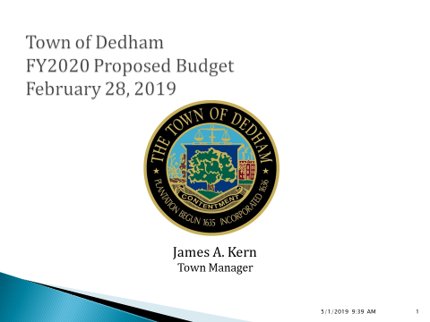

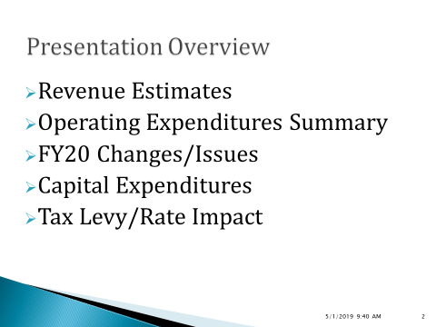

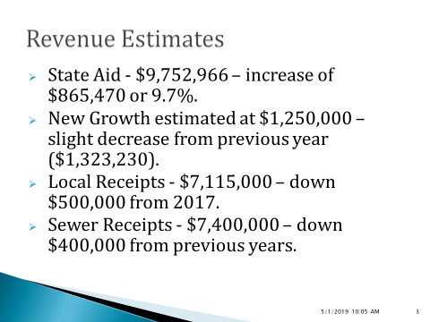

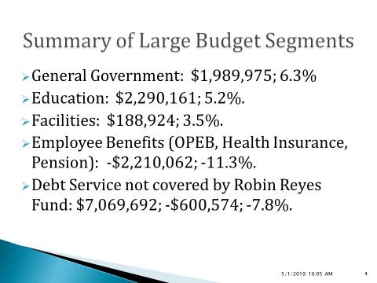

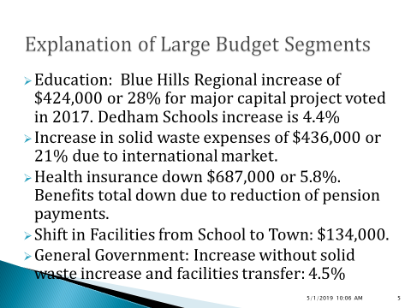

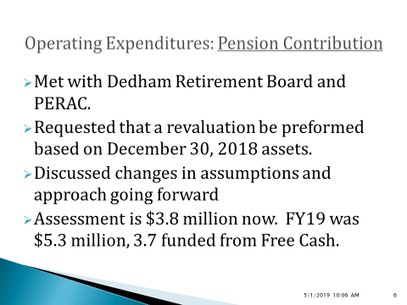

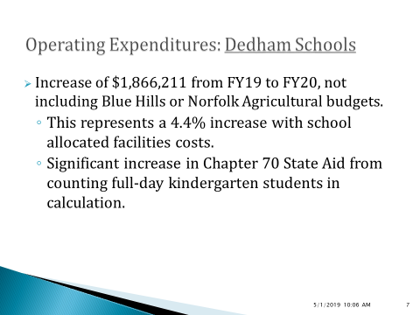

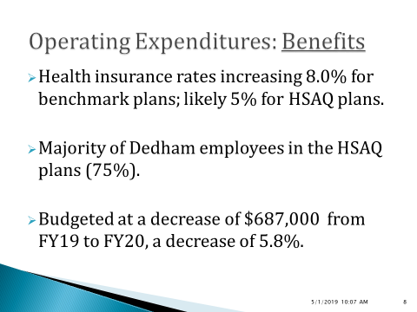

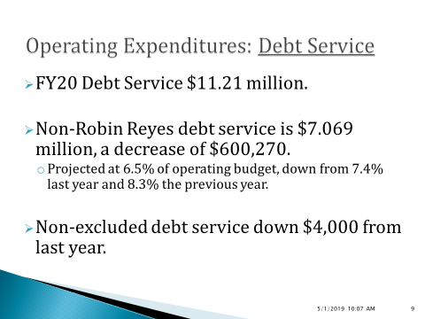

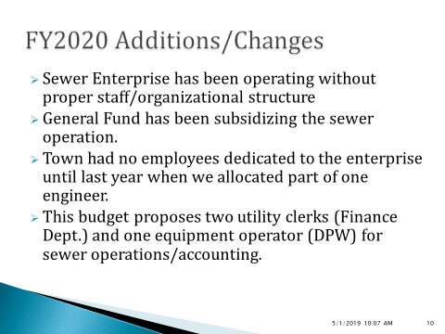

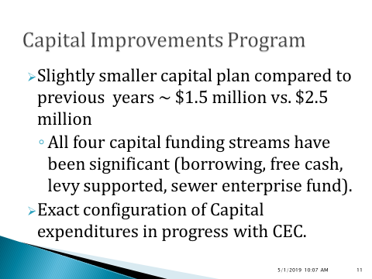

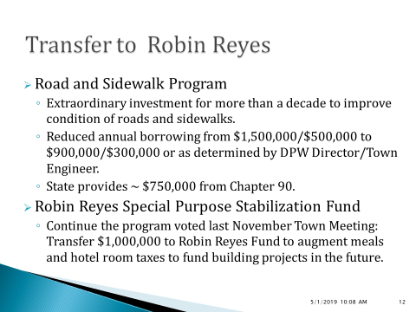

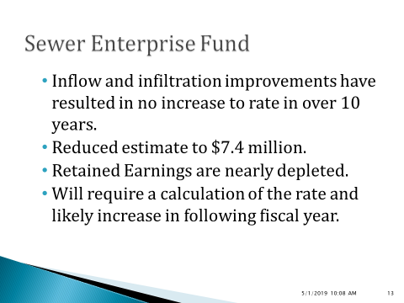

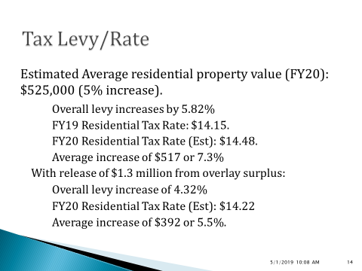

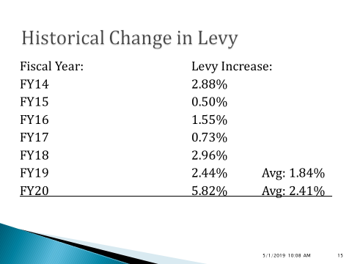

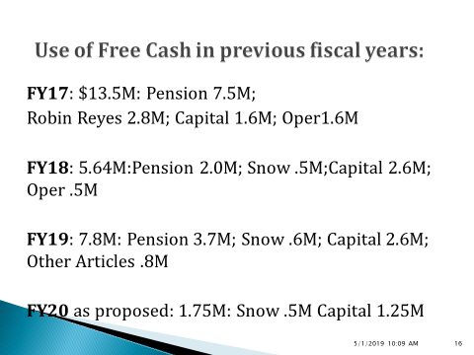

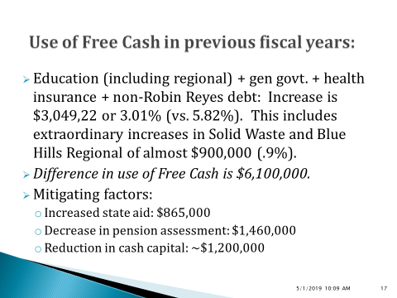

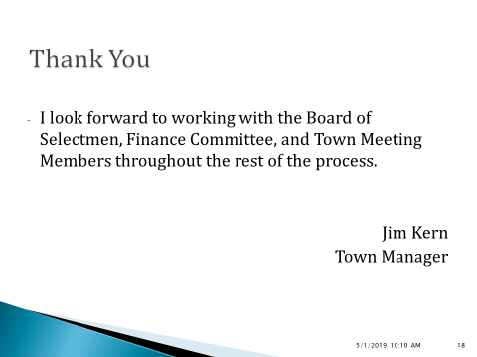

Dr. Teehan expressed gratitude to the Town for supporting the Blue Hills Technical School. Dr. Teehan added that Mr. Kern has done a tremendous job with the budget especially with health care costs.

Dr. Teehan then stated that he would like to talk about the pension. Dr. Teehan added that the normal cost the pension is going to be around $1.5 million. Dr. Teehan pointed out that last year we paid $5.1 million. Dr. Teehan continued, saying that the $3.6 million are paying this year is better than $5.1 million but he still unconvinced as to why we should be paying anything above the normal cost at this point. Dr. Teehan informed everyone that Dedham’s pension fund is in the top 3 in the state. Dr. Teehan stated that the Board is asking for a. 5.8% potential increase in taxes this year and yet we are also having this $2 million, above normal, payment to the pension fund. Dr. Teehan stated that he is looking forward to the dialogue pertaining to this.

Mr. MacDonald stated that this budget is a true reflection of Mr. Kern’s fiscal knowledge and experience putting together and delivering a budget report.

**Discussion & Vote Re: Disposition of Compliance Failure Violation Hearings for: The Irish Alehouse, Inc., d/b/a Waterford’s, 2-4 Bridge Street;**

**Maureen Skehill, Manager; Cow Island, Inc. d/b/a Moseley’s on the Charles, 50 Bridge Street; Edward DeVincenzo, Manager; PMA Beverage Services II d/b/a The Hilton at Dedham Place, 25 Allied Drive; Brian Patrick Smith, Manager; Oscar Bar Dedham, LLC d/b/a Oscar’s, 380 Washington Street; Michael Tallon, Manager; Ark Video Corp. d/b/a Dedham Square Coffee House, 565 High Street; Ali Koushan, Manager AND Disposition of Violation Hearing (Failure to Maintain Manager of Record) for BBRG Dedham TR, LLC d/b/a Joe’s American Bar & Grill, 985 Providence Highway; Ryan Taylor, Manager.**

HILTON - FINDING(S)

Mr. Butler moved to find that the licensee, PMA beverage services

II, d/b/a the Hilton at Dedham Place, 25 Allied Dr., did violate Massachusetts Gen. laws chapter 138, section 34 [ sale or delivery of alcohol to a person under 21 years of age], 204 CMR 2.05 (2) [permitting any disorder, disturbance or illegality of any kind to take place in or on the licensed premises], and/or the Rules and Regulations for holders of alcoholic beverage licenses in the Town of Dedham, #23 [sale or delivery to a person under 21 years of age] as outlined in the December 6, 2018 Police Report; seconded by Mr. Guilfoyle. **On the Vote:** Mr. Keogh, yes, Dr. Teehan, yes, Mr. Butler, yes, Mr. Guilfoyle, yes, Mr. MacDonald, yes.

HILTON – SANCTION(S)

Mr. Butler moved that a written warning be issued regarding the all alcoholic restaurant license issued to PMA beverage services II D/B/A the Hilton at Dedham Place, 25 Allied Dr.; seconded by Mr. Guilfoyle. **On the Vote:** Mr. Keogh, yes, Dr. Teehan, yes, Mr. Butler, yes, Mr. Guilfoyle, yes, Mr. MacDonald, yes.

WATERFORD’S – FINDING(S)

Mr. Guilfoyle moved to find that the licensee, the Irish Alehouse, Inc. d/b/a Waterford’s, 2 – 4 Bridge St., did violate Massachusetts Gen. laws chapter 138, section 34 [sale or delivery of alcohol to a person under 21 years of age], 204 CMR 2.05 (2) [permitting any disorder, disturbance or illegality of any kind to take place in or on the licensed premises], and/or the Rules and Regulations for holders of alcoholic beverage licenses in the Town of Dedham, #23 [sale or delivery to a person under 21 years of age] as outlined in the December 6, 2018 Police Report; seconded by Dr. Teehan. **On the Vote:** Mr. Keogh, yes, Dr. Teehan, yes, Mr. Butler, yes, Mr. Guilfoyle, yes, Mr. MacDonald, yes.

WATERFORD’S – SANCTION(S)

Mr. Guilfoyle moved that a written warning be issued regarding the all alcohol restaurant license issued to the Irish Alehouse, Inc. D/B/A Waterford’s, 2 – 4 Bridge St.; seconded by Dr. Teehan. **On the Vote:** Mr. Keogh, yes, Dr. Teehan, yes, Mr. Butler, yes, Mr. Guilfoyle, yes, Mr. MacDonald, yes.

OSCARS – FINDING(S)

Dr. Teehan moved to find that the licensee, Oscar Bar Dedham, LLC D/B/A Oscar’s, 380 Washington St., did violate Massachusetts Gen. laws chapter 138, section 34 [sale or delivery of alcohol to a person under 21 years of age], 204 CMR 2.05 (2) [permitting any disorder, disturbance or illegality of any kind to take place in or on the licensed premises], and/or the Rules and Regulations for holders of alcoholic beverage licenses in the Town of Dedham, #23 [sale or delivery to a person under 21 years of age] as outlined in the December 6, 2018 Police Report; seconded by Mr. Guilfoyle. **On the Vote:** Mr. Keogh, yes, Dr. Teehan, yes, Mr. Butler, yes, Mr. Guilfoyle, yes, Mr. MacDonald, yes.

OSCARS - SANCTION(S)

Dr. Teehan moved that a written warning be issued regarding the all alcohol restaurant license issued to Oscar bar Dedham, LLC. D/B/A Oscar’s, 380 Washington St. seconded by Mr. Guilfoyle. **On the Vote:** Mr. Keogh, yes, Dr. Teehan, yes, Mr. Butler, yes, Mr. Guilfoyle, yes, Mr. MacDonald, yes.

DEDHAM SQUARE COFFEE HOUSE – FINDING(S)

Mr. Keogh moved to find that the licensee, Ark Video Corporation D/B/A Dedham Square Coffee House, 565 High St., did violate Massachusetts Gen. laws chapter 138, section 34 [sale or delivery of alcohol to a person under 21 years of age], 204 CMR 2.05 (2) [permitting any disorder, disturbance or illegality of any kind to take place in or on the licensed premises], and/or the Rules and Regulations for holders of alcoholic beverage licenses in the Town of Dedham, #23 [sale or delivery to a person under 21 years of age] as outlined in the December 6, 2018 Police Report; seconded by Mr. Guilfoyle. **On the Vote:** Mr. Keogh, yes, Dr. Teehan, yes, Mr. Butler, yes, Mr. Guilfoyle, yes, Mr. MacDonald, yes.

DEDHAM SQUARE COFFEE HOUSE – SANCTION(S)

Mr. Keogh moved that a written warning be issued regarding the wine and malt restaurant license issued to Ark video Corporation d/b/a Dedham Square coffee House, 565 High St.; seconded by Mr. Guilfoyle. **On the Vote:** Mr. Keogh, yes, Dr. Teehan, yes, Mr. Butler, yes, Mr. Guilfoyle, yes, Mr. MacDonald, yes.

MOSELEY’S – FINDING(S)

Mr. Butler moved to find that the licensee, Cowell Island, Inc. D/B/A Moseley’s on the Charles, 50 Bridge St., did violate Massachusetts Gen. laws chapter 138, section 34 [sale or delivery of alcohol to a person under 21 years of age], 204 CMR 2.05 (2) [permitting any disorder, disturbance or illegality of any kind to take place in or on the licensed premises], and/or the Rules and Regulations for holders of alcoholic beverage licenses in the Town of Dedham,#23 [sale or delivery to a person under 21 years of age] as outlined in December 6, 2018 Police Report; seconded by Mr. Keogh. **On the Vote:** Mr. Keogh, yes, Dr. Teehan, yes, Mr. Butler, yes, Mr. Guilfoyle, yes, Mr. MacDonald, yes.

Mr. Butler stated that the six license holders before us tonight, this is the more complicated one because of its history of previous violations. Mr. Butler added that subsequent to those 2 violations, the Board held a hearing and during the hearing the Board decided that in total there would be seven days suspended, of the seven days, 3 were served and four were held in abeyance. Mr. Butler continued, saying that typically the Board holds those days in abeyance for time frame of 12 months but given the nature of the offenses discussed with the license holder, the Board voted to hold those four days in abeyance for 24 months. The hearing was held in January 2017 and four days in question were held in abeyance until January 2019. Mr. Butler added that if any violation occurred within that 24 months, the Board has the option to vote to activate those four days. Mr. Butler informed all that the most recent violation occurred in December 2018, so 23 months after the previous violation hearing is when compliance check a Moseley’s failed. Mr. Butler continued, saying that the Board needs to weigh this most recent compliance failure on December 6, 2018 and Moseley’s performance in the 23 months after the hearing of January 2017. Mr. Butler stated that the Board has a range of options.

MOSELEY’S – SANCTION(S)

Mr. Butler moved that the all alcohol restaurant license issued to Cow Island, Inc. d/b/a Moseley’s on the Charles, 50 Bridge St., be suspended for a period of one (1) day, said day originally imposed and held in abeyance as a result of action by the Board due to incidents occurring in March and October 2016; and that an additional three (3) day suspension to be imposed for the compliance failure on December 6, 2018, three (3) days to be held in abeyance for a period of Twelve (12) months, said twelve (12) months, to expire February 28, 2020. This action results in a suspension of the all alcohol restaurant license issued to Cow Island, Inc. d/b/a Moseley’s on the Charles, 50 Bridge St., for one (1) day, said one (1) day to be served on Thursday, March 14, 2019; seconded by Dr. Teehan. **On the Vote:** Mr. Keogh, yes, Dr. Teehan, yes, Mr. Butler, yes, Mr. Guilfoyle, yes, Mr. MacDonald, yes.

Joe’s American Bar and Grill

Failure to maintain manager of record, for BBRG Dedham TR, LLC d/b/a Joe’s American Bar and Grill, 985 Providence Hwy.; Ryan Taylor, manager

Mr. Butler stated that what he gathered from the hearing two weeks ago was that there is a gap of about 30 days from when the manager of record left Joe’s and a new application was put forth. Mr. Butler added that he did not think going 30 days between manager and application rose to the punishment of the sanction. Mr. Butler continued, saying that he believes asking the Town Manager’s office to write a letter to the license holder to remind them of this particular regulation.

Mr. Butler moved that the Board ask the Town Manager’s office to read a letter to the license holder to remind them of the 15 day regulation between managers of record; seconded by Mr. Guilfoyle. **On the Vote:** Mr. Keogh, yes, Dr. Teehan, yes, Mr. Butler, yes, Mr. Guilfoyle, yes, Mr. MacDonald, yes.

**Vice-Chairman’s Report**

Question regarding the different construction going on:

Bridge Street

Dedham Mall

Ken Cimeno, Building Commissioner, informed Mr. Keogh that there is some work going on near 80 Bridge Street. Permits for a partial demolition of the interior as well as a partial exterior demolition. The owner still working with the architect. The owner has not applied for a permit to do a reconstruction.

There are three vacant spots in the Dedham Mall - Toys “R” Us spot, the Sears’s automotive spot plus the second floor of Sears’s automotive spot. The owner is working to get those spots filled.

**Old/New Business**

Mr. Guilfoyle recognized Bob Laumann, who recently passed away.

Mr. Butler stated that Bob Norberg passed away recently. Mr. Butler added that Mr. Norberg was an excellent carpenter and fundraiser. He will definitely be missed.

Mr. Keogh informed all that the school building rehabilitation committee (SBRC) held a meeting this past Monday at the new ECEC. Mr. Keogh added that the building looks absolutely beautiful.

Mr. MacDonald asked for a motion to adjourn the Meeting.

Mr. Guilfoyle moved to adjourn the Meeting; seconded by Mr. Keogh. **On the Vote:** Mr. Keogh, yes, Dr. Teehan, yes, Mr. Butler, yes, Mr. Guilfoyle, yes, Mr. MacDonald, yes.

The Meeting was adjourned at 8:45pm.

The next Meeting is scheduled for Thursday March 7, 2019. This is to certify that the above is a true and accurate record of the minutes of the Selectmen’s Meeting held on February 28, 2019, which minutes were approved on May 8, 2019.

___________________________

James A. MacDonald.–Chairman