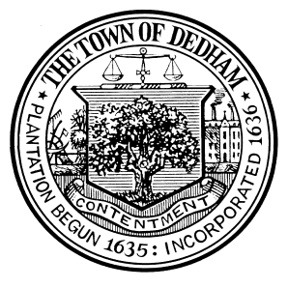 | TOWN OF DEDHAM  MEETING  NOTICE | POSTED:  TOWN CLERK

POSTED IN ACCORDANCE WITH THE PROVISIONS OF M.G.L. CHAPTER 30A SECTION 20 AS AMENDED

Mother Brook 375th Anniversary Committee
Discussion & Vote on Gears, Benches & Markers
Old/ New Business

PLACE OF MEETING: Mother Brook Arts & Community Center, 123 High Street
DAY, DATE & TIME: Thursday, March 21, 2019 at 7:00 p.m.

CANCELLED

MEETING OF __________________________ POSTED TO __________________________

___________________________

Signature
___________________________
Date

